# **Linear Regression model Part-1**

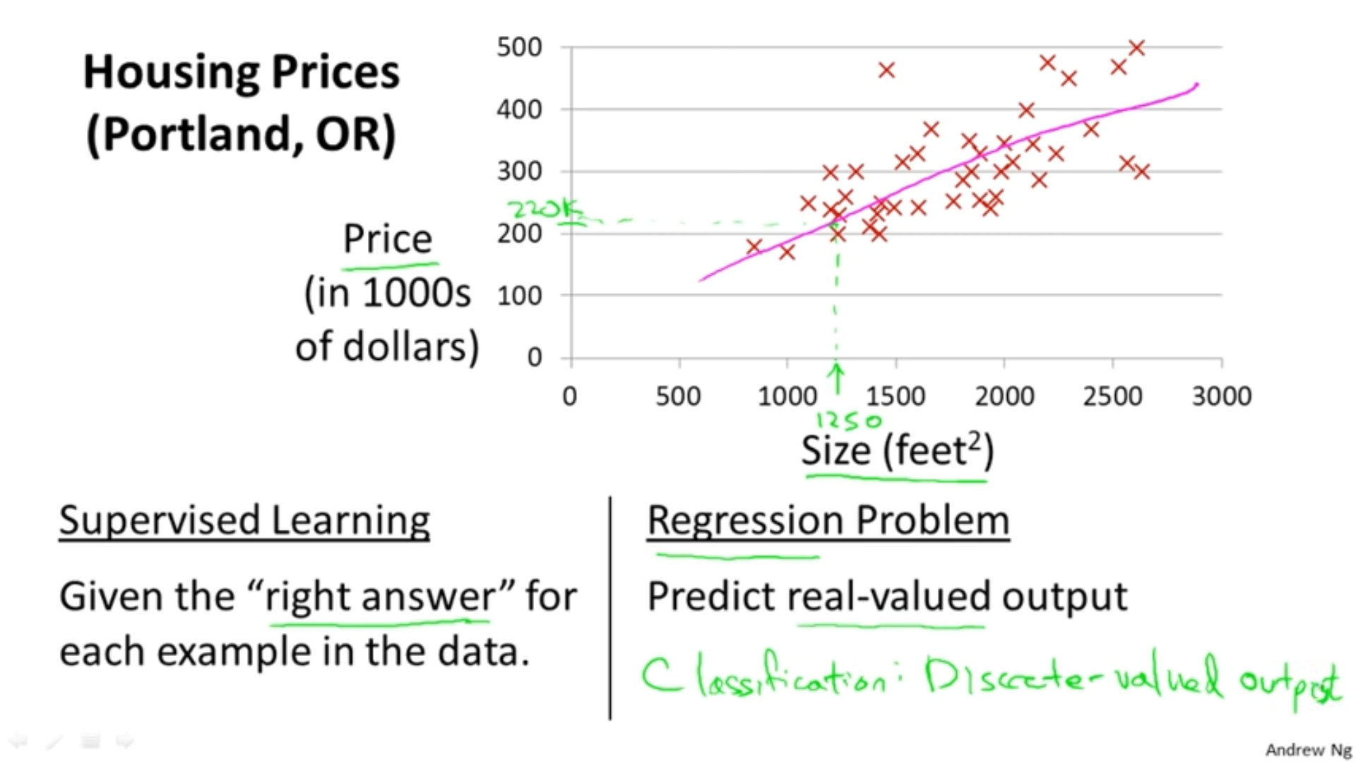

## **Terminologies**



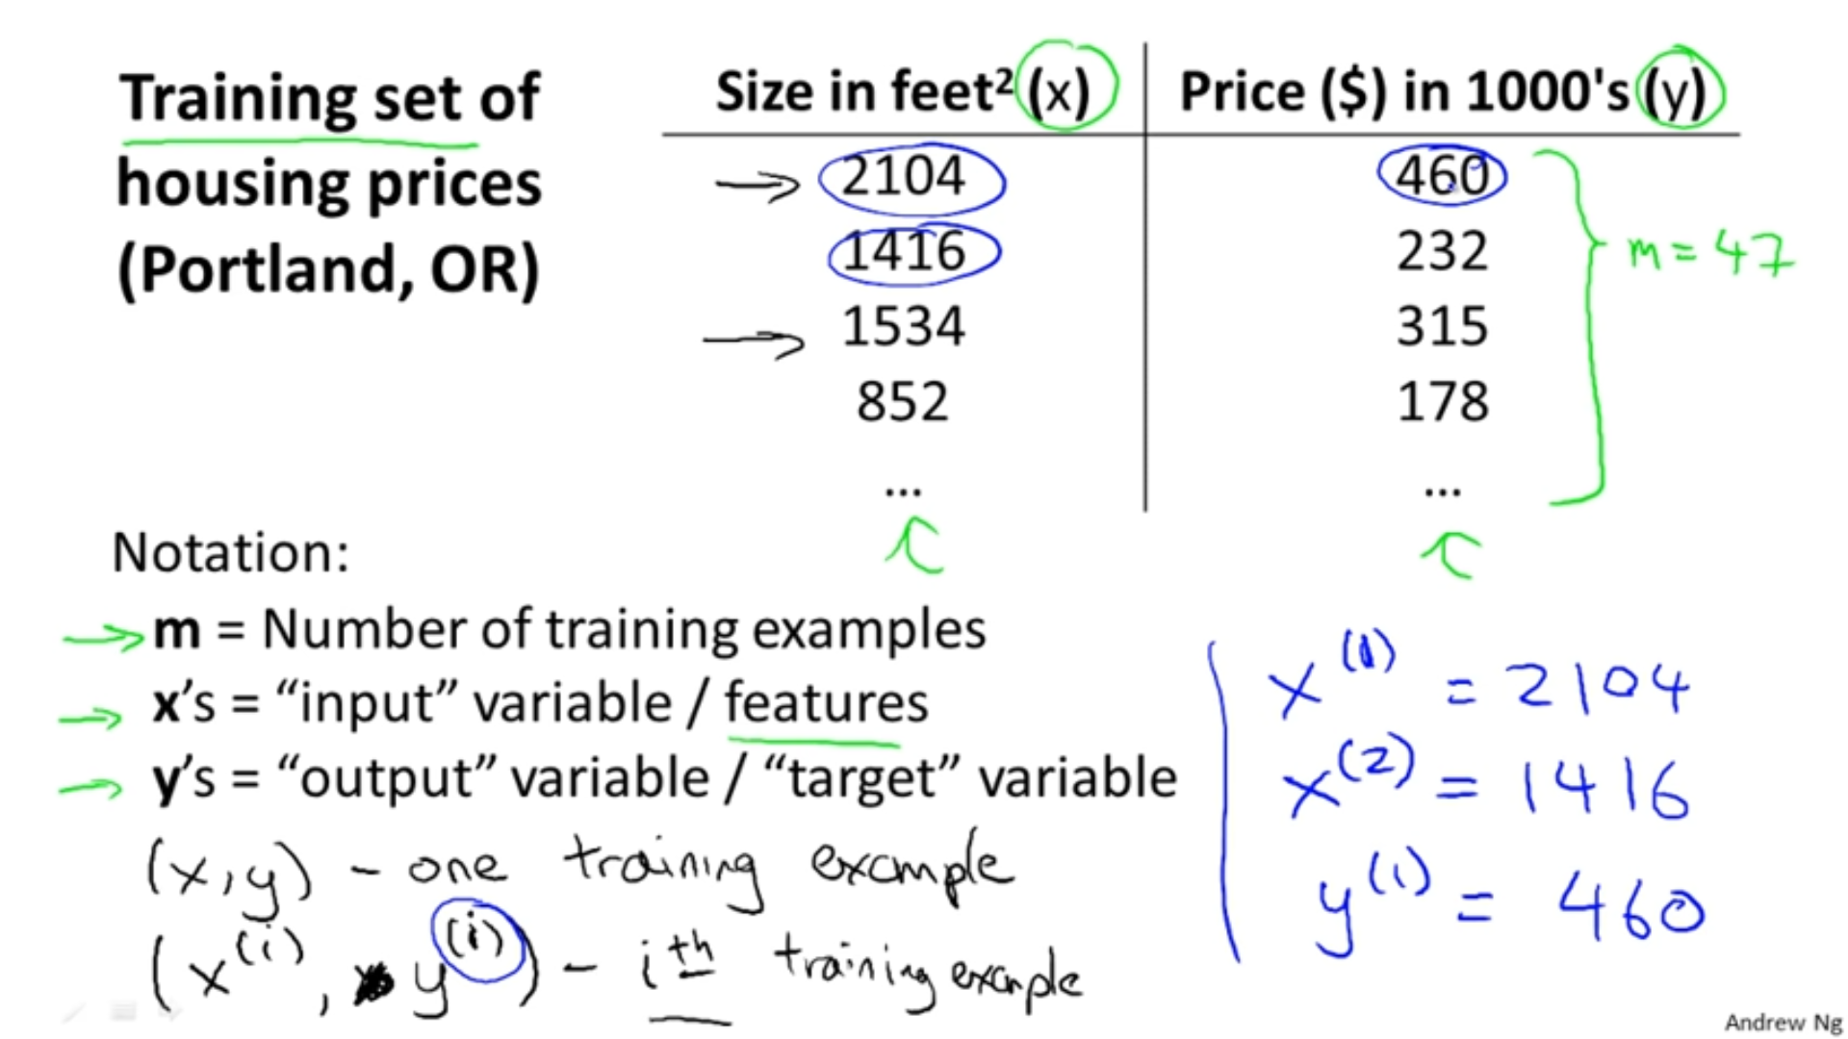

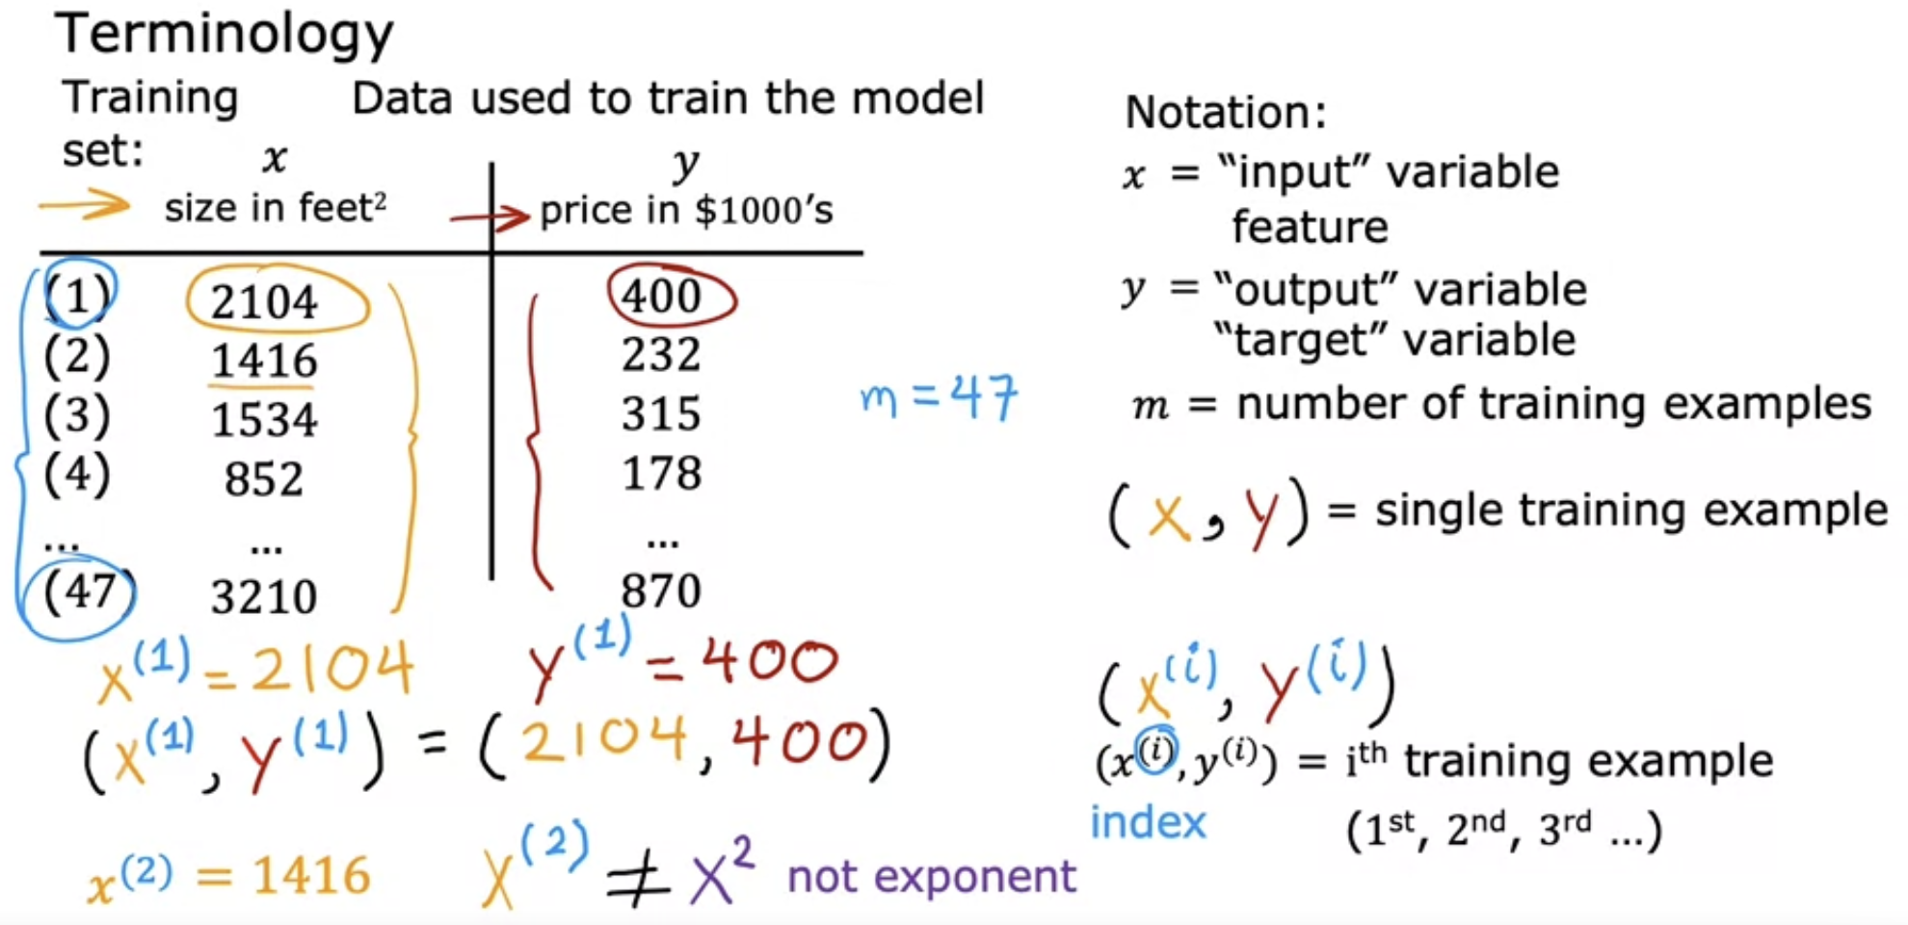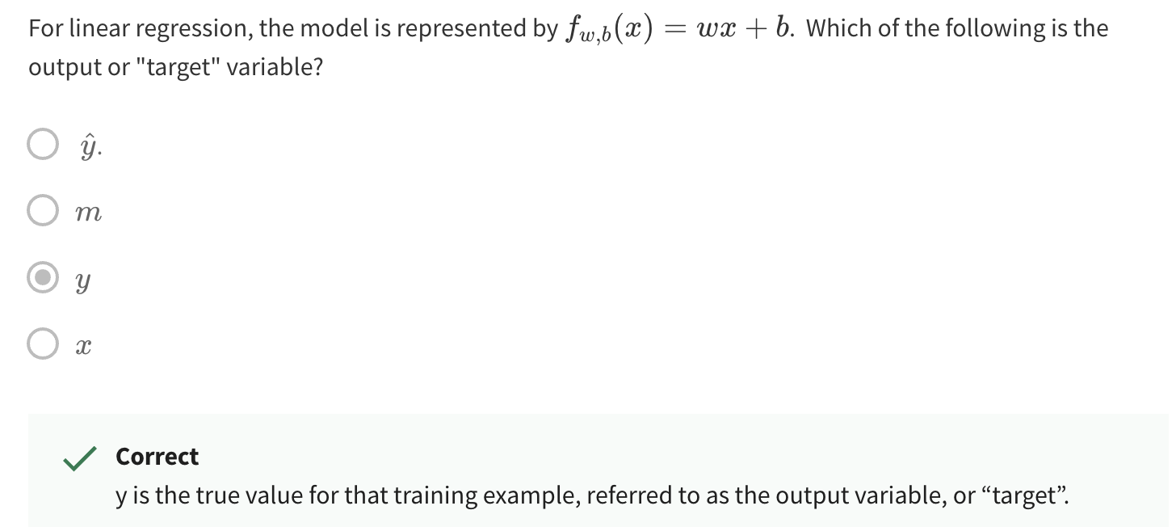

# **Linear Regression model Part-2**

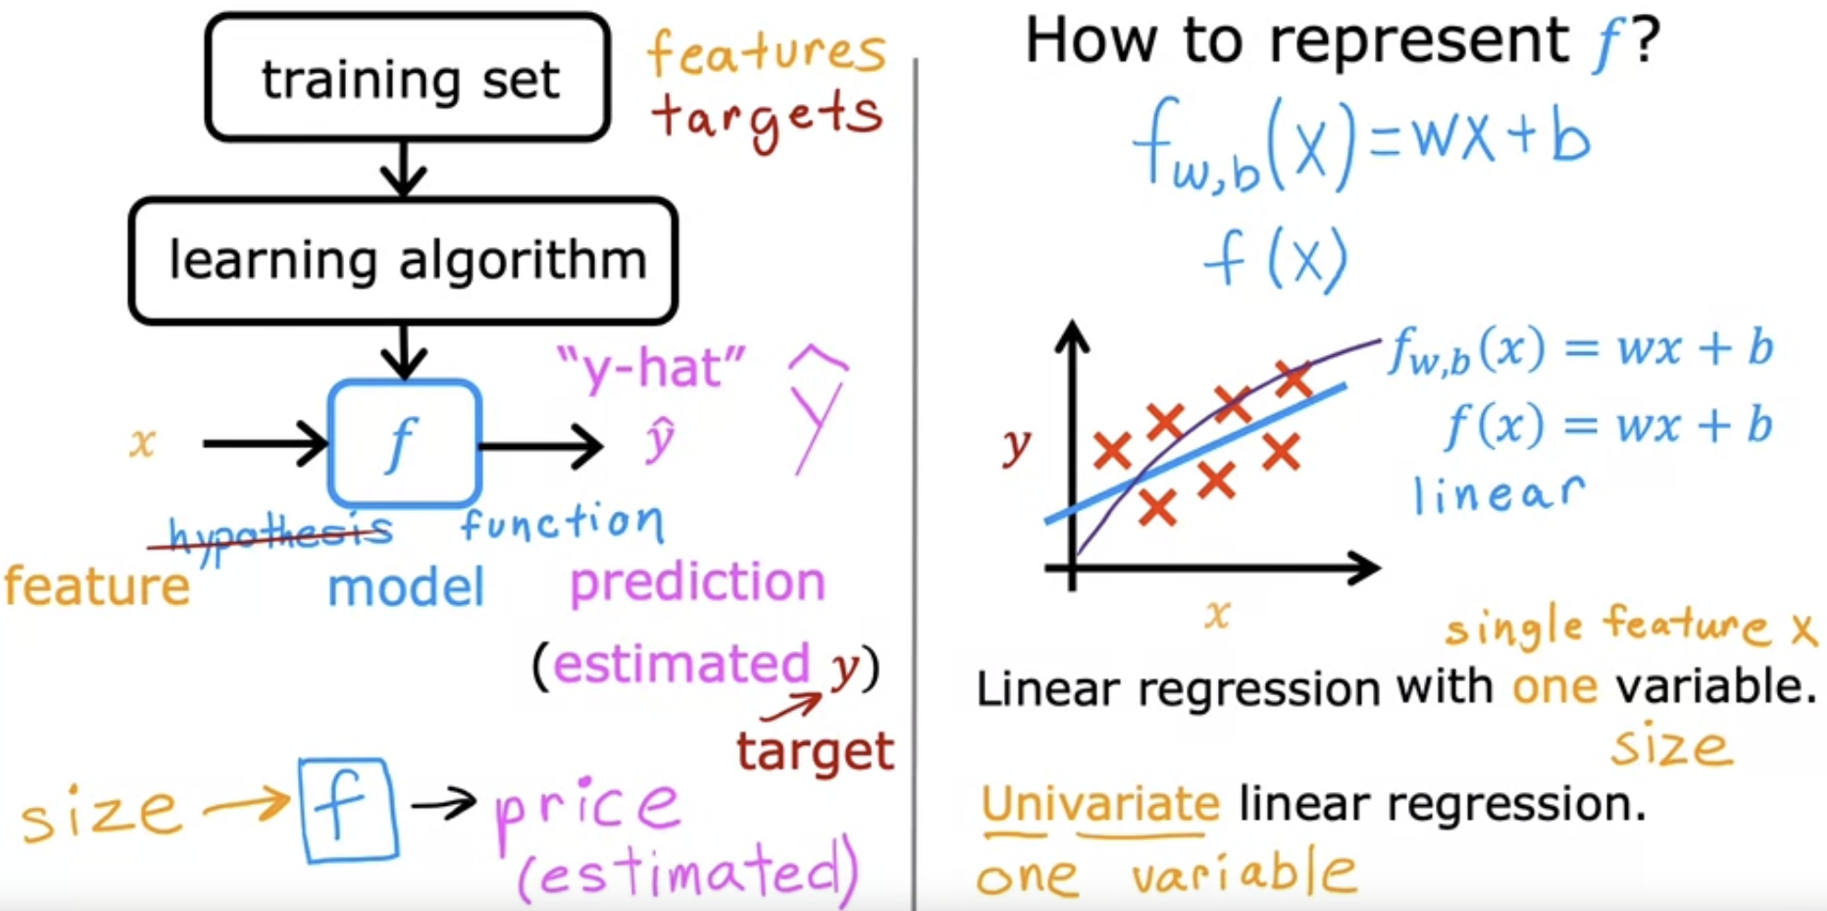

The function f is also know as function/hypothesis/model.

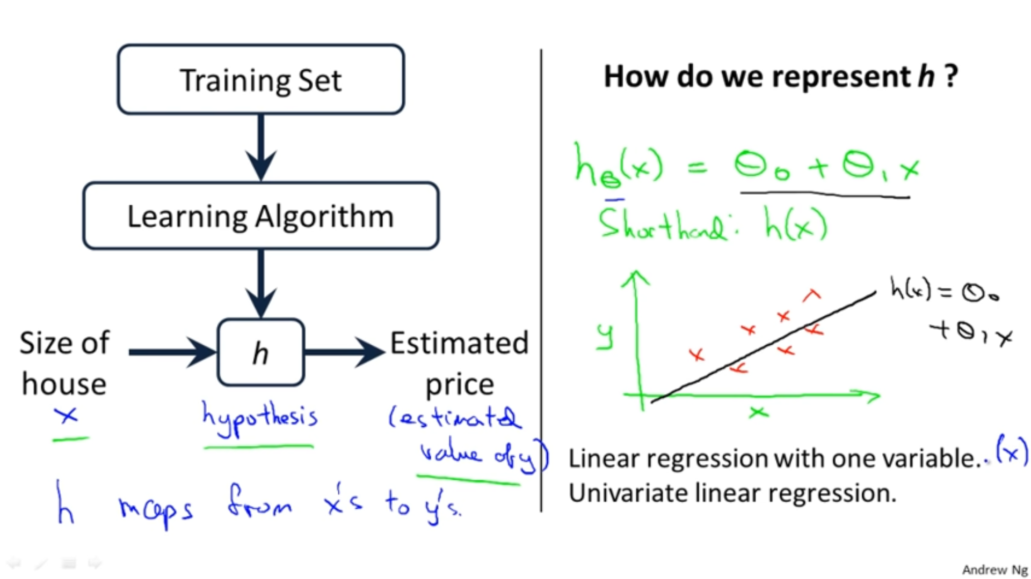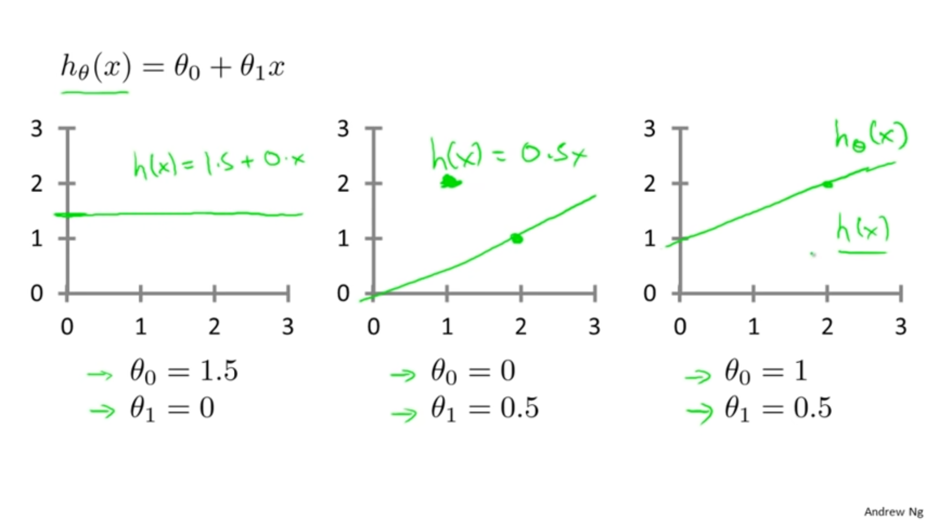

h(x) 🡪 0x + 1.5 h(x) 🡪 1.5x + 0 h(x) 🡪 0.5x + 1

**Cost function/Squared error function/Residual Sum of Squares**

Average square of the distance between the observed and the predicted value

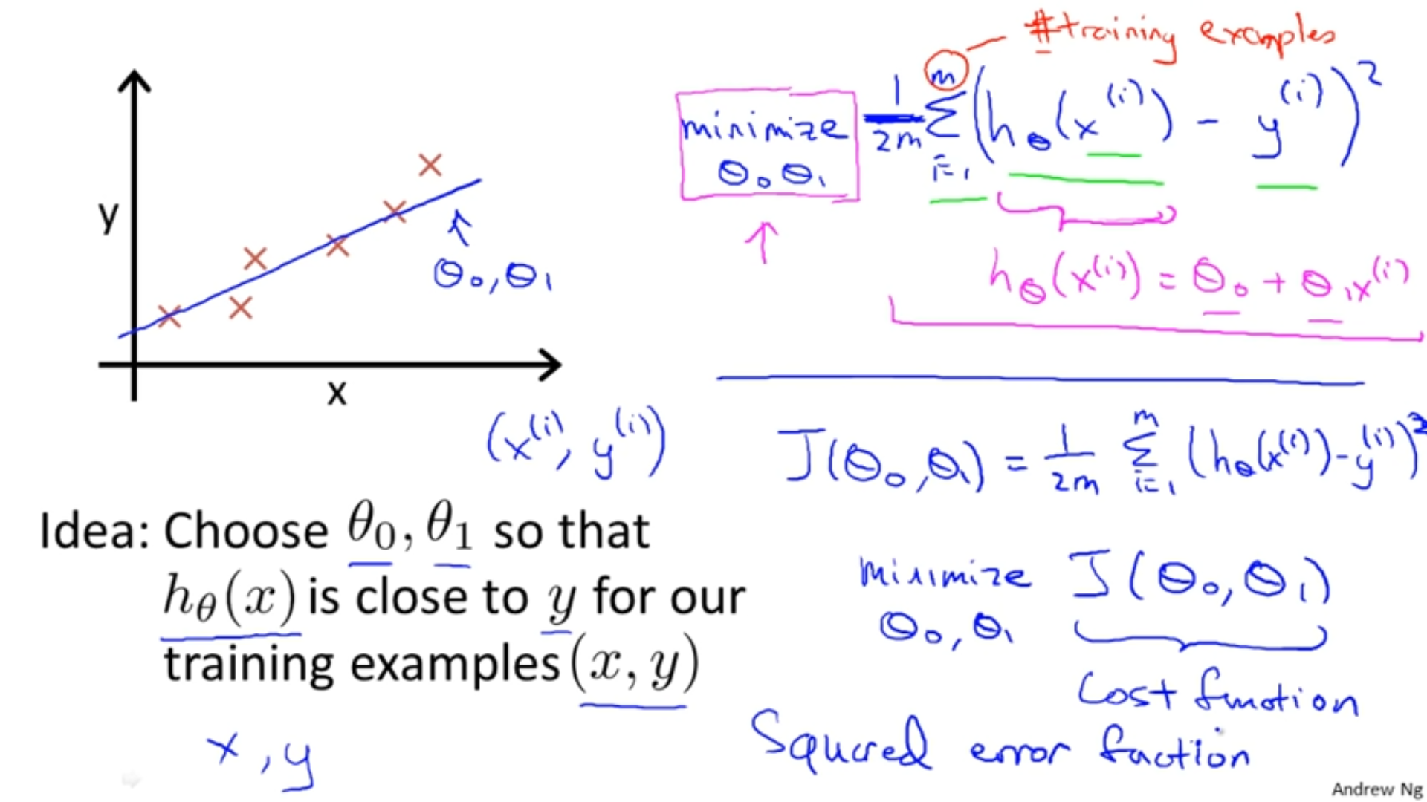



**Intuition behind the cost function**

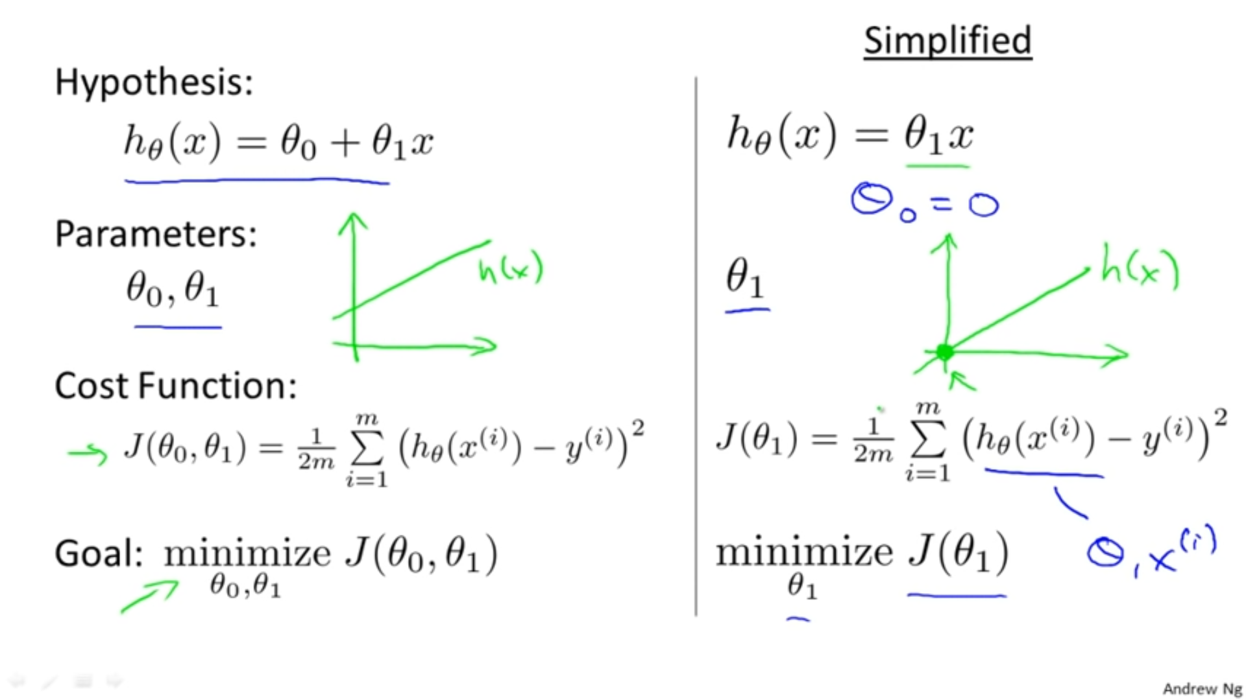

=1



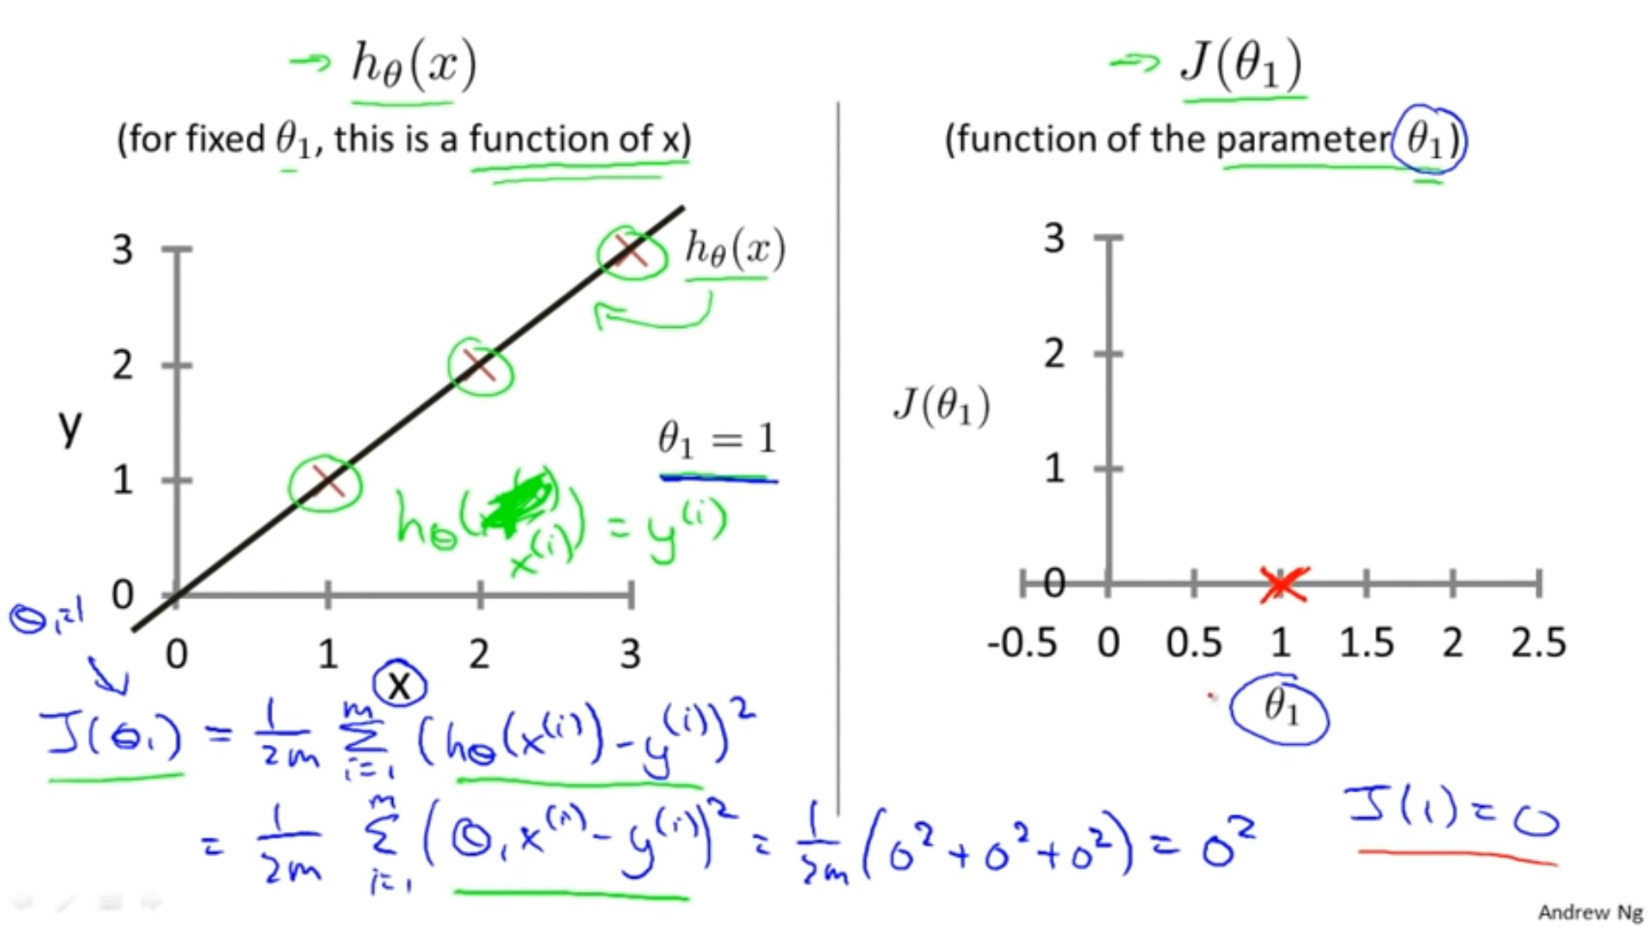



0.5



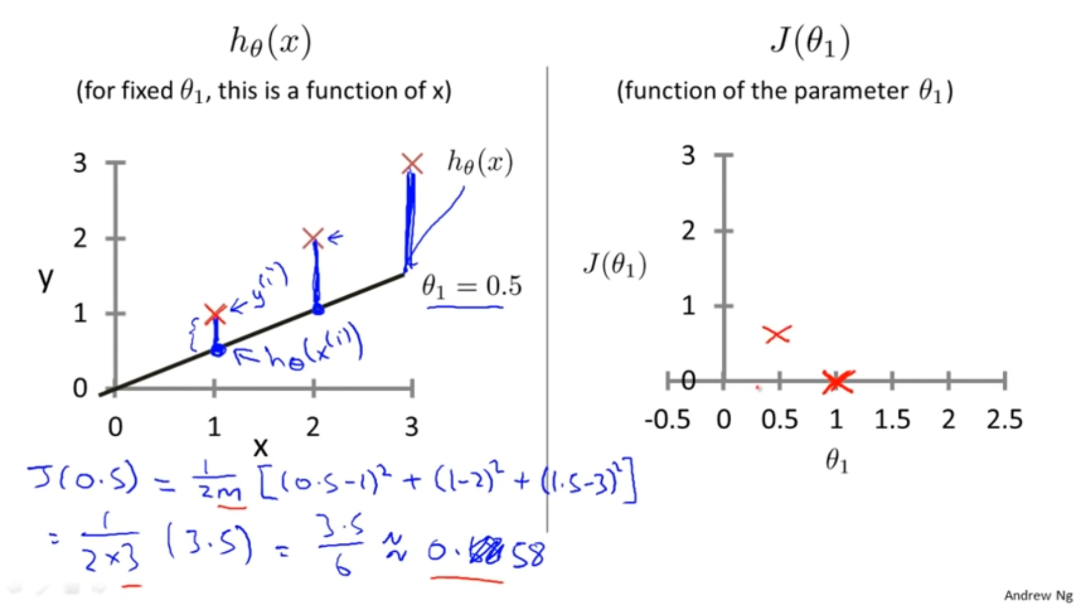

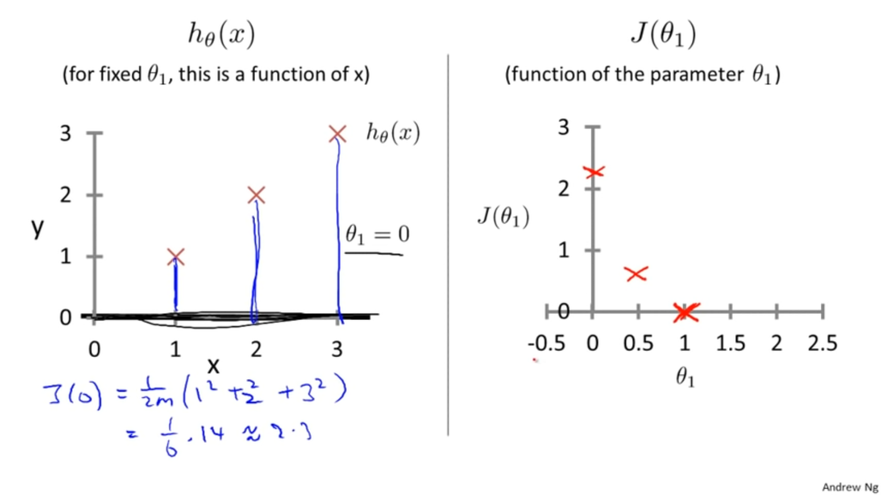

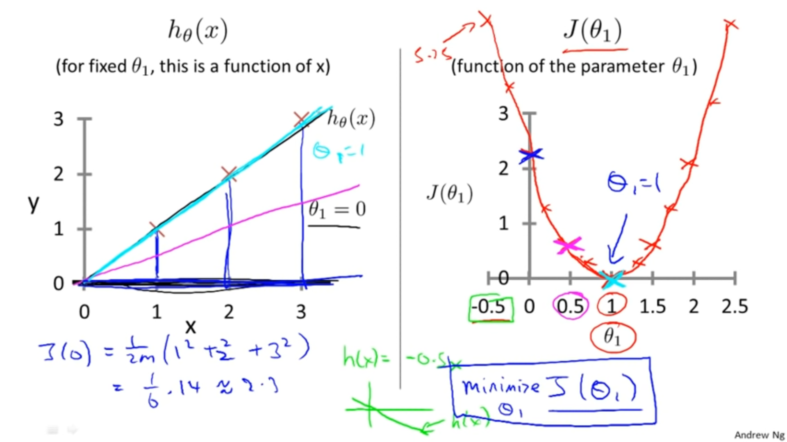



Over here we want to choose for which J( ) should be minimum. Hence for =1, the cost function is minimum



**Cost function**

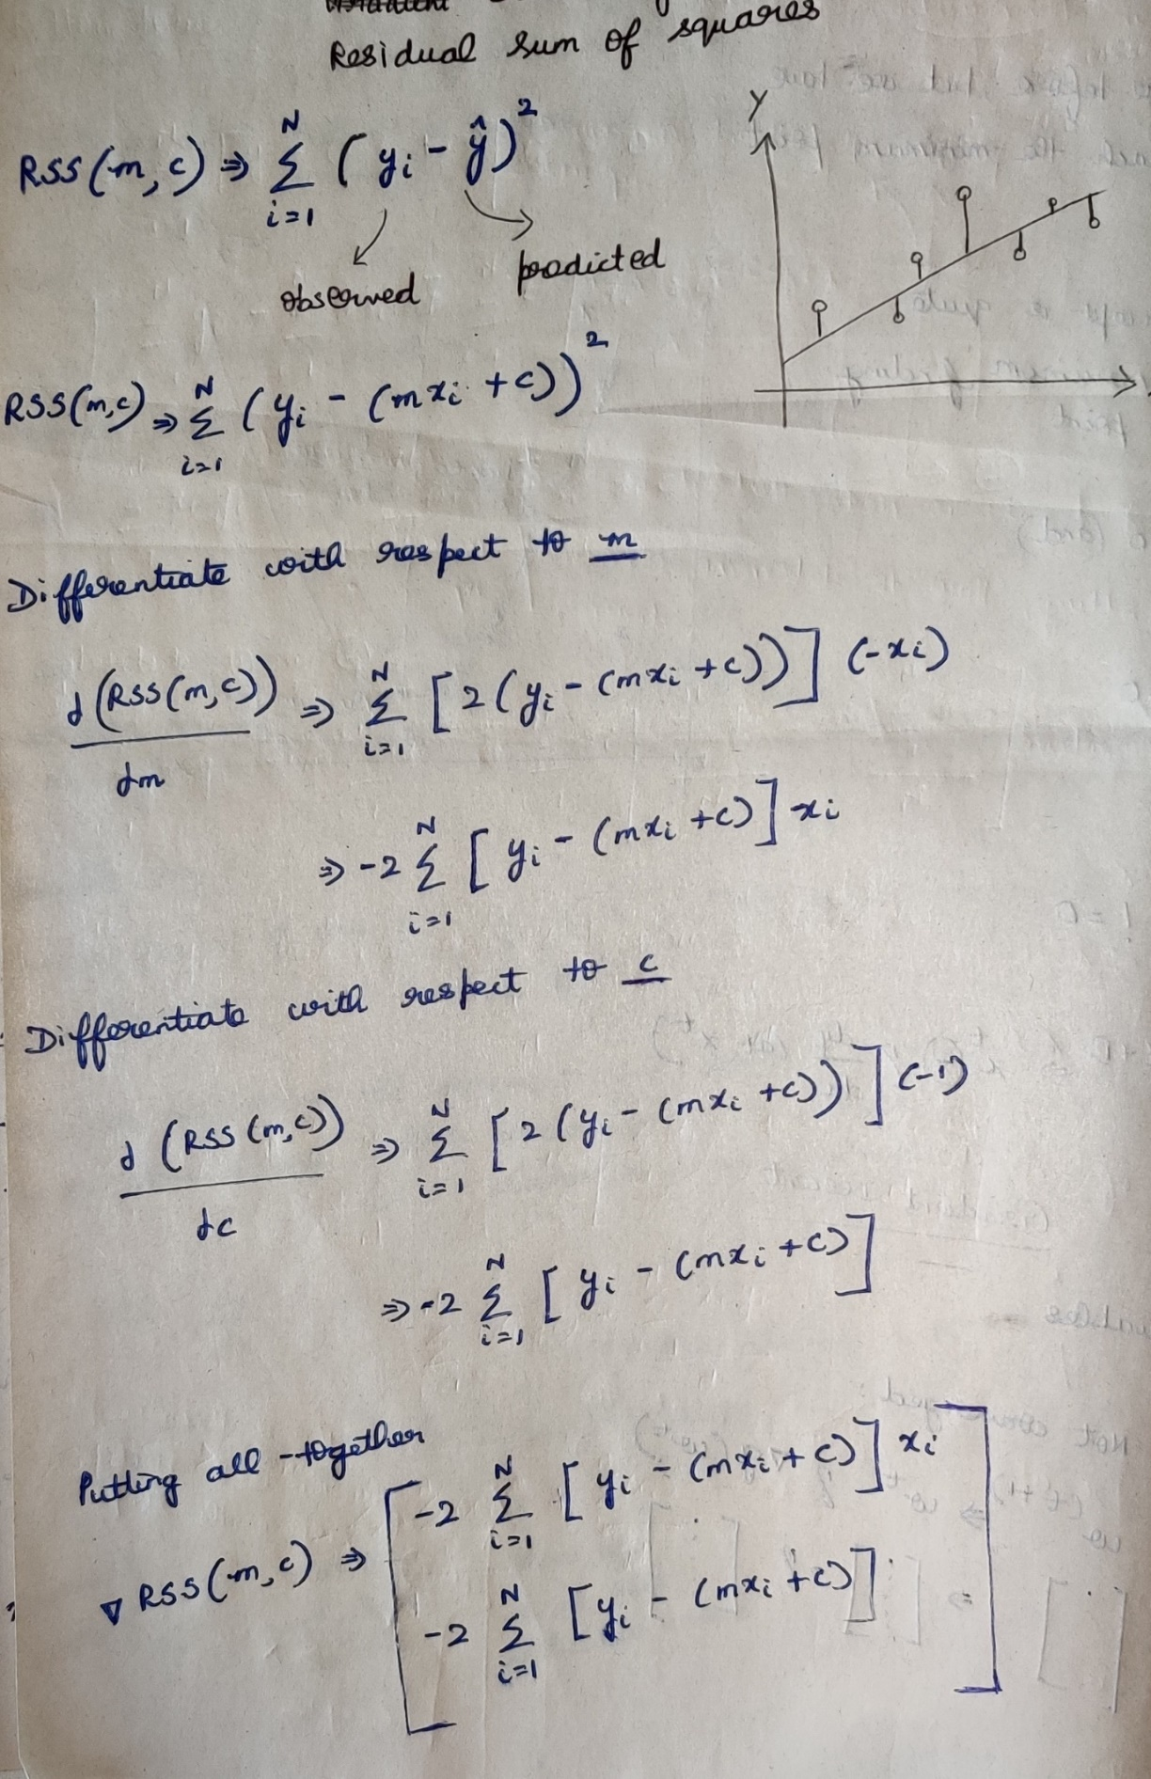



# **Approach-1 Closed form Solution**

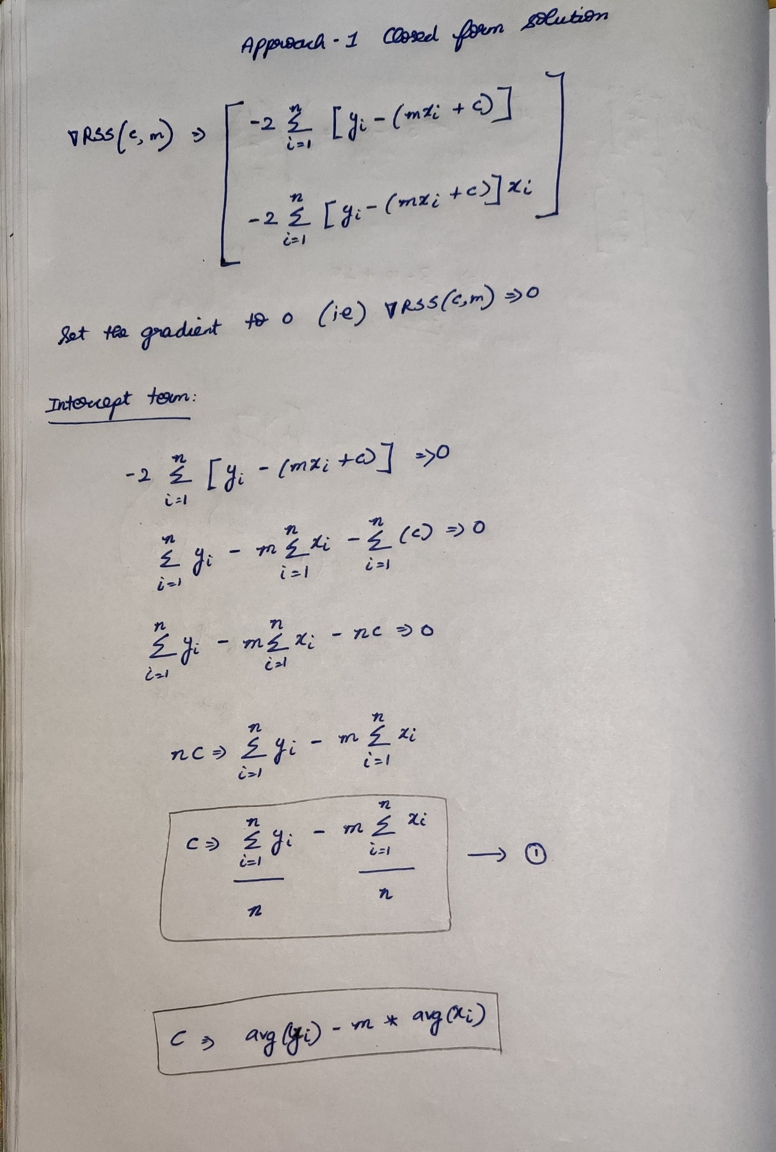

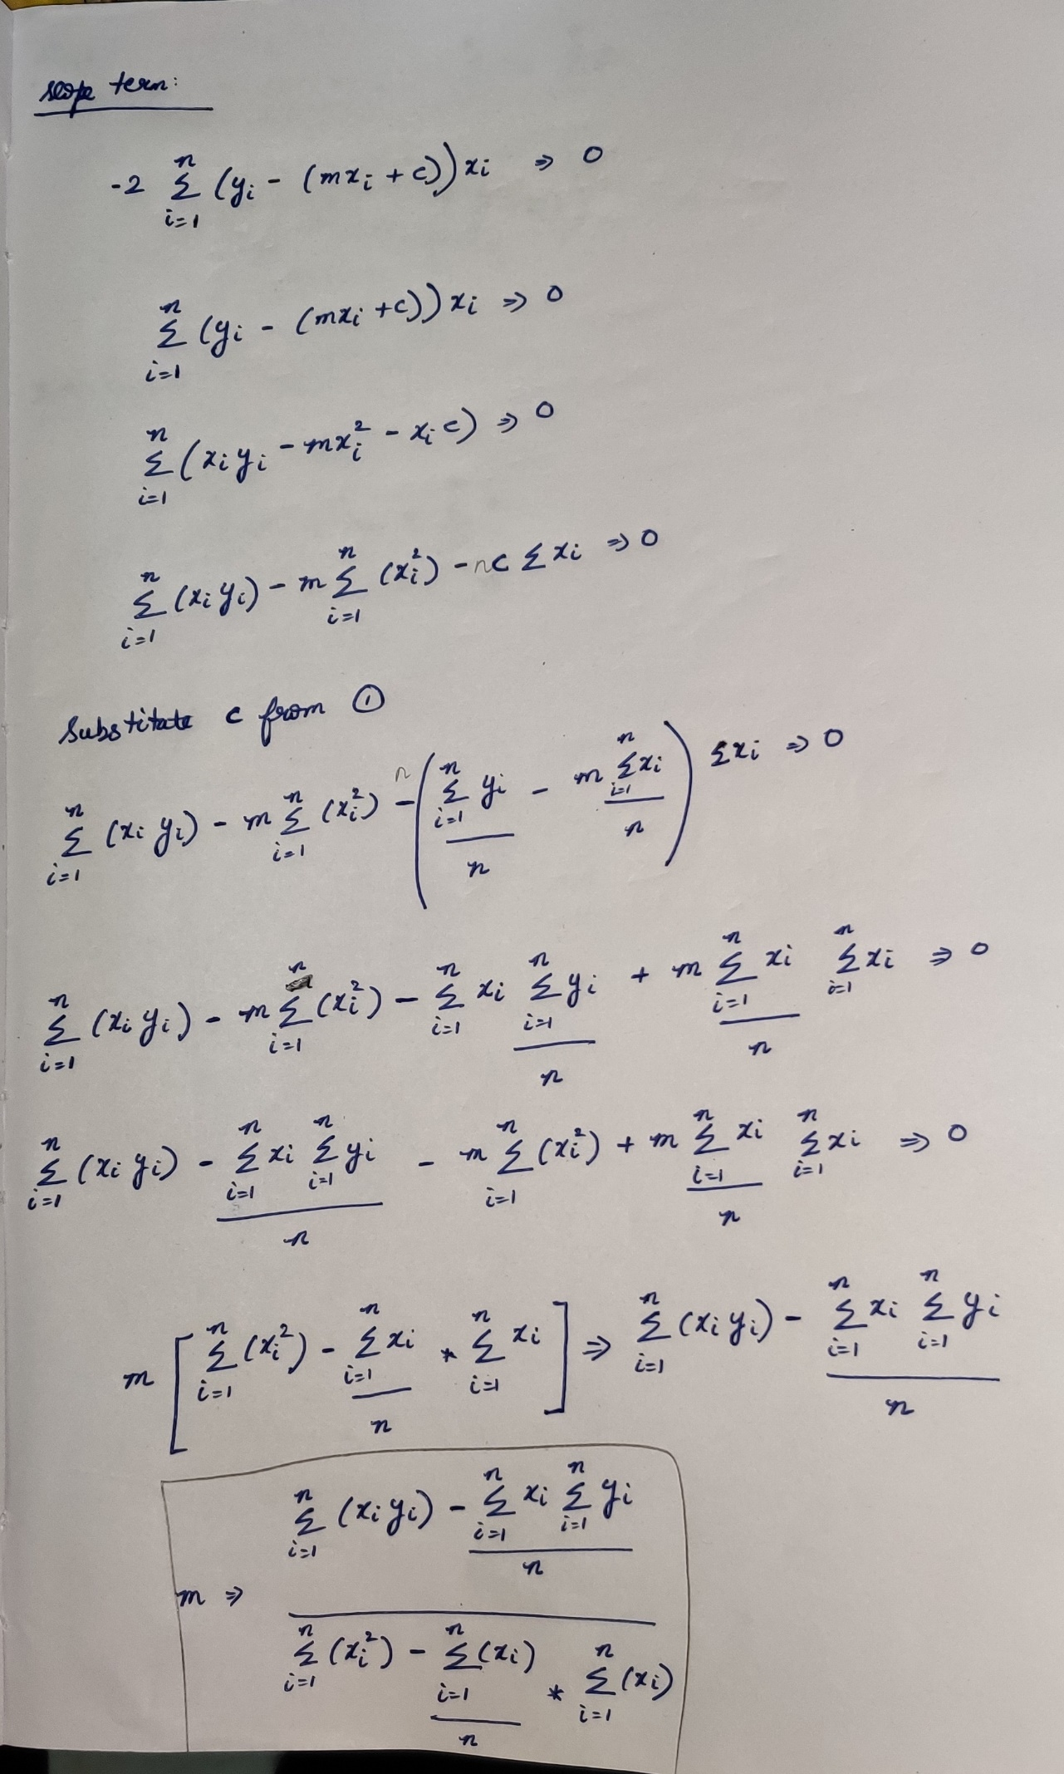



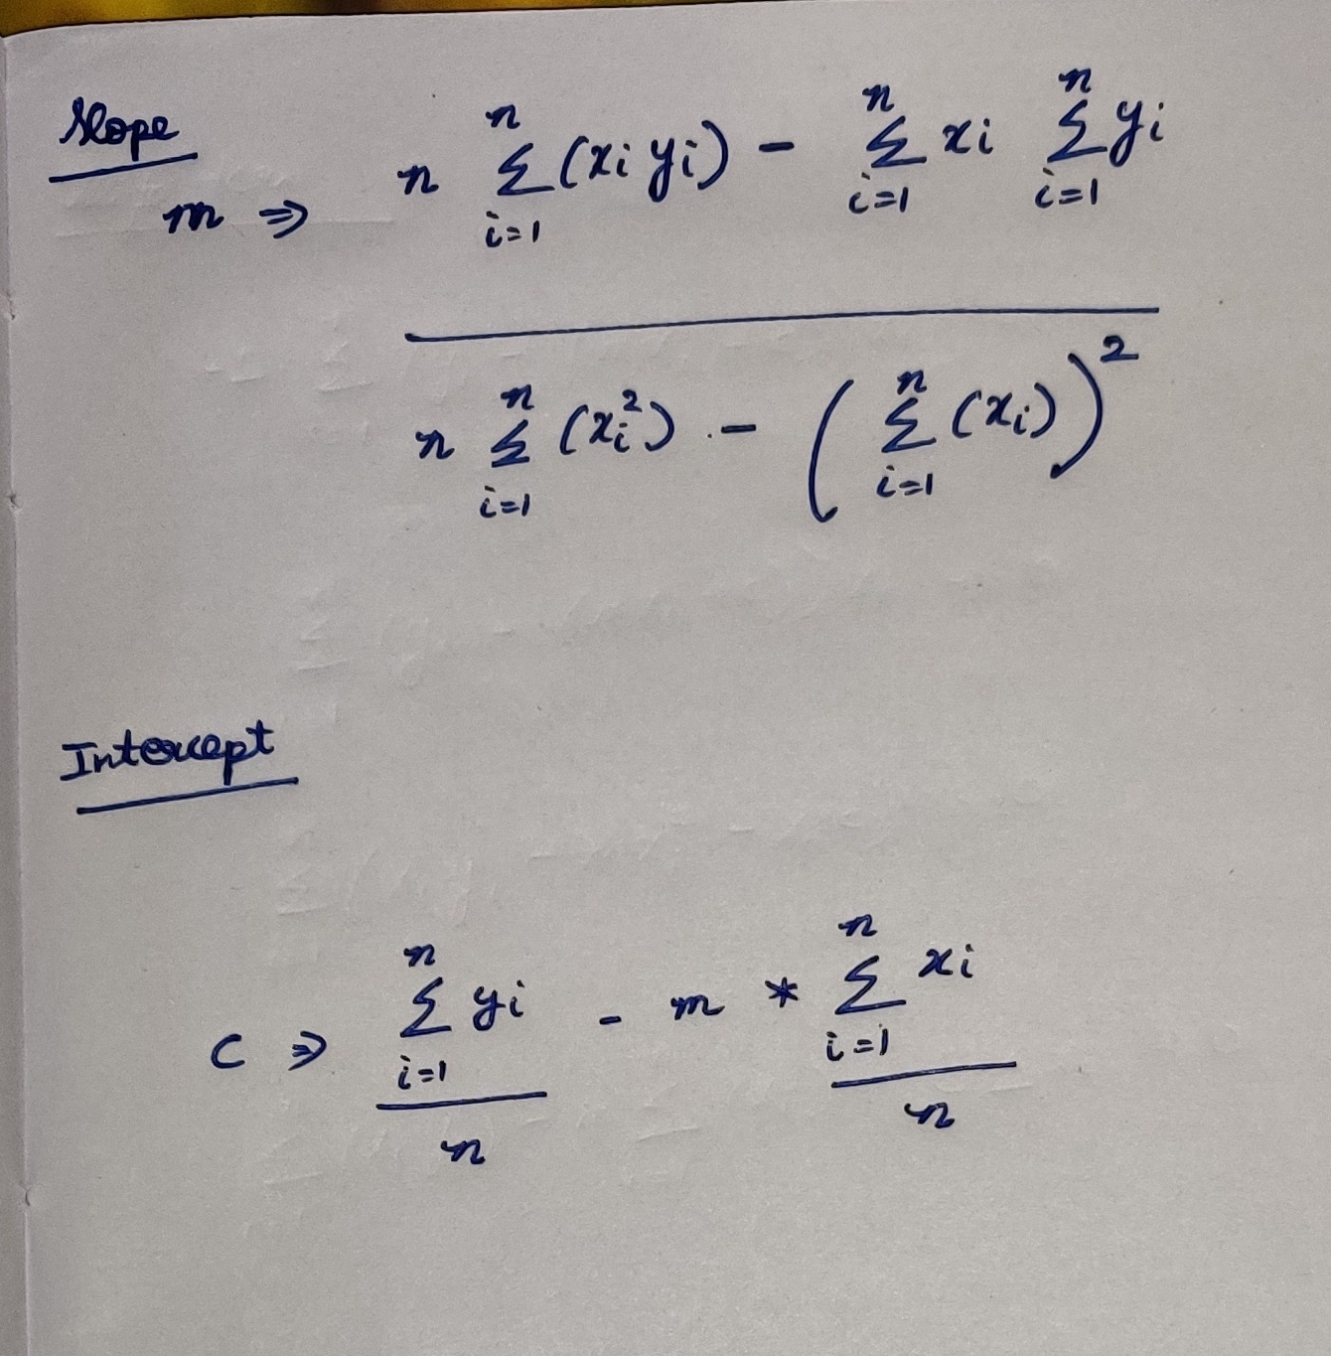

# **Approach-2 Gradient Descent Algorithm**

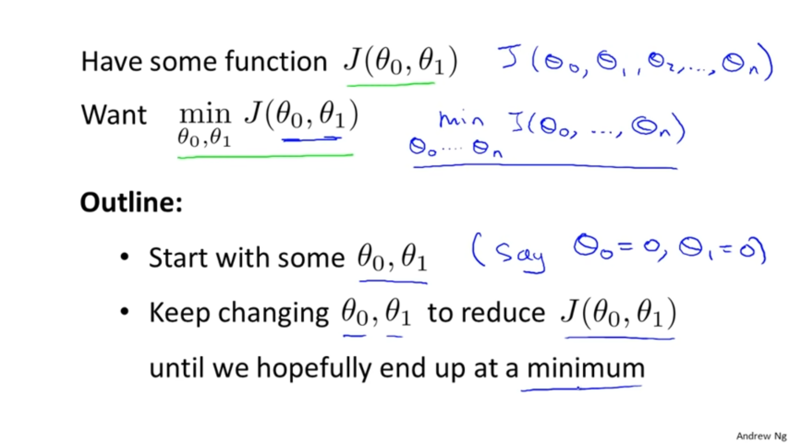

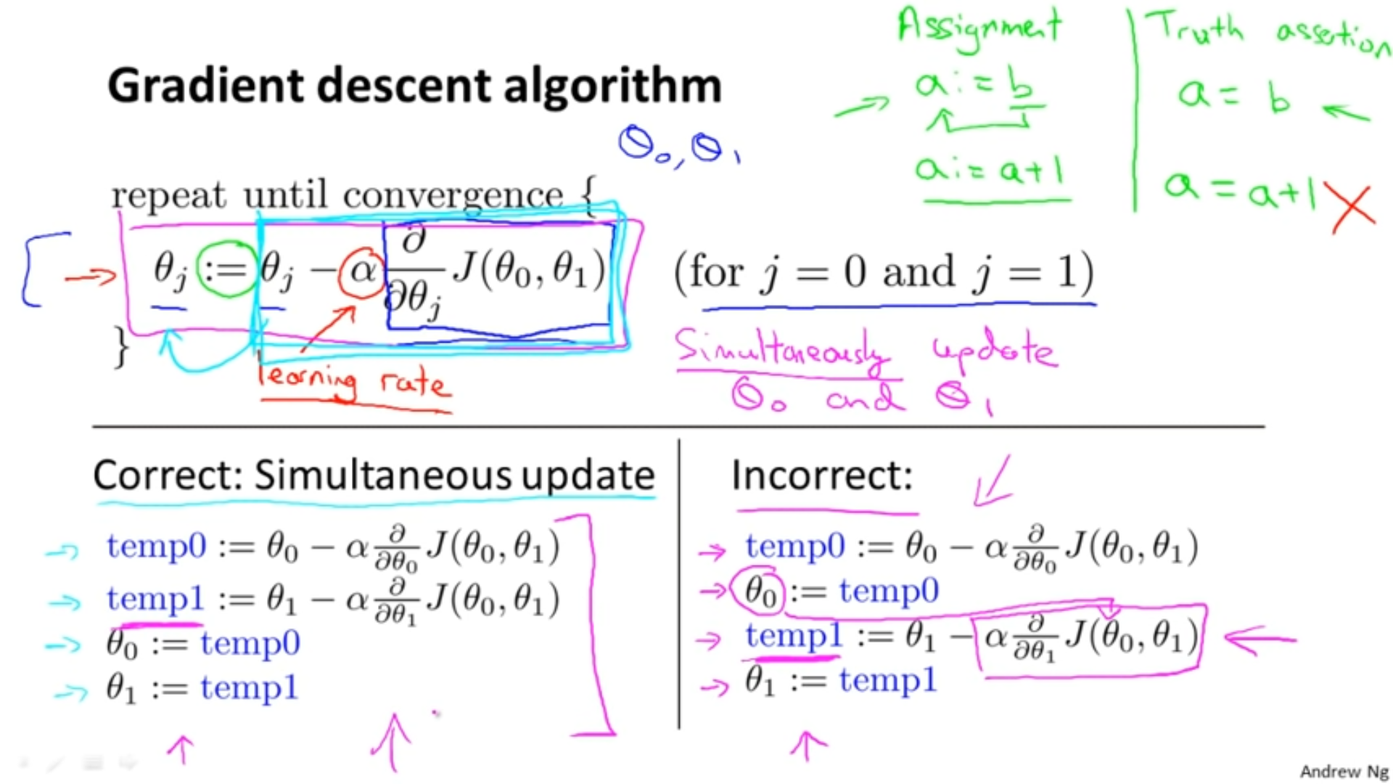



**Positive slope**

+ve number



So will be reduced and will move towards the left.



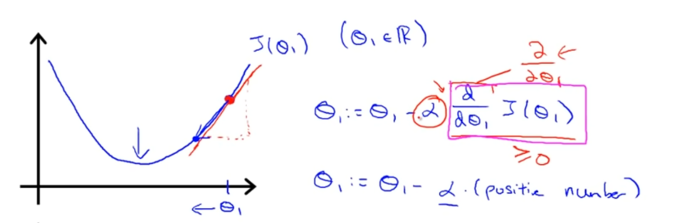

**Negative slope**

-ve number



So will be larger and will move towards the right.



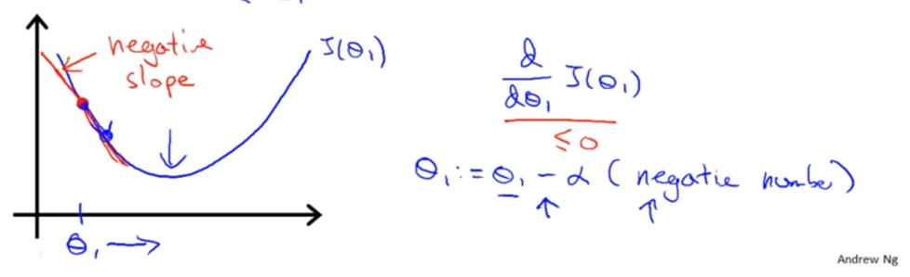

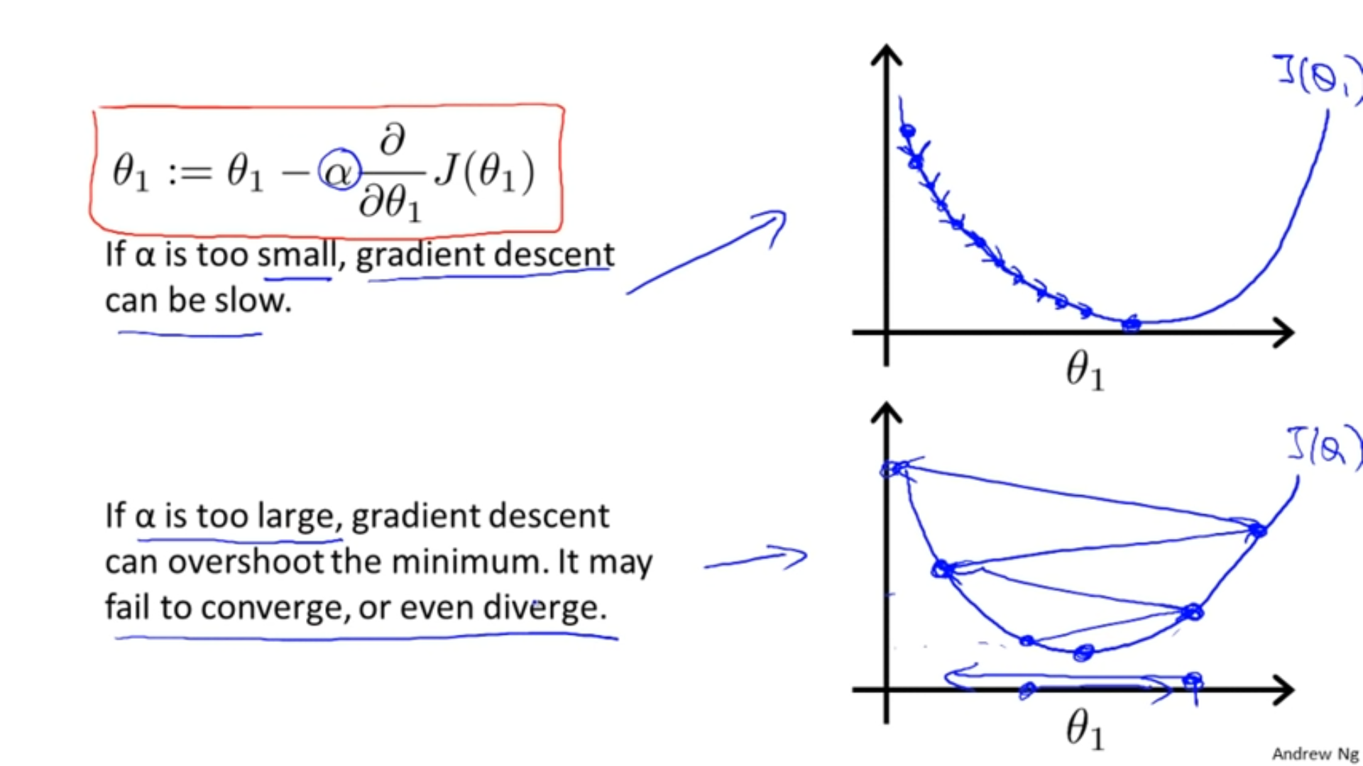

**Question:**

If one of the parameter ( ) is already at the local minimum, then what the gradient descent will give????



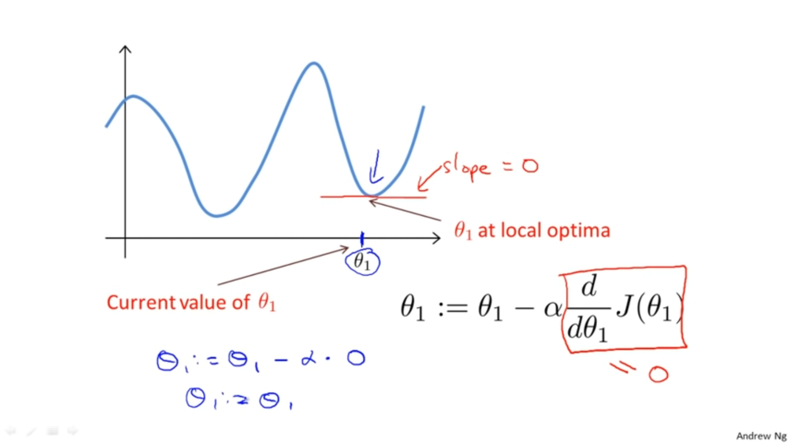

At that minimum point, the slope=0 , * 0 🡪0.   
And therefore the slope doesn’t change.



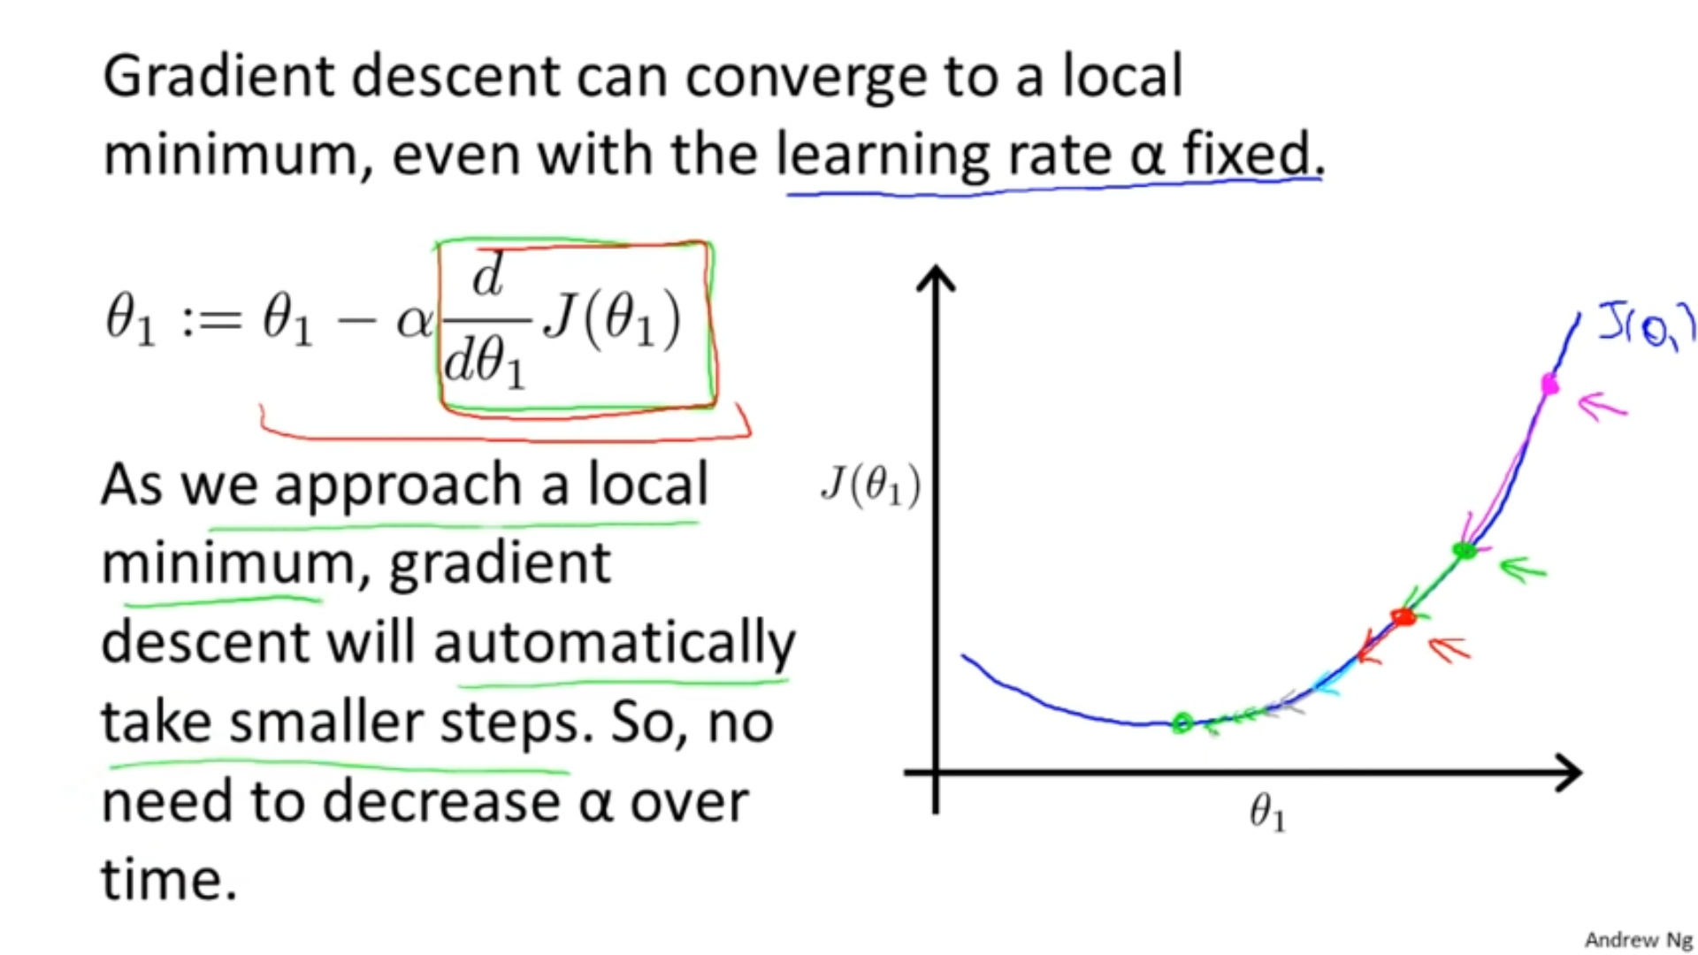

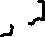

Slope at the green point is less steep that the slope at the magenta point.  
So the slope at the green point is reduced than the slope at magenta point. So it will take smaller steps.   
Hence the gradient descent will take smaller steps when it approaches the local minimum.

**Gradient Descent Algorithm for Linear Regression**

Cost function of Linear regression is always a bow-shaped function.(i.e Convex function).  
This function will not have any local optimum except for the one global optimum.

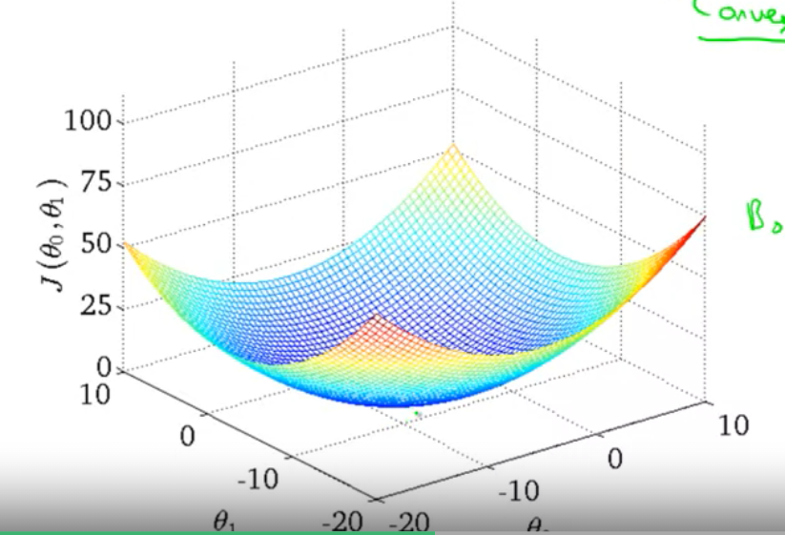 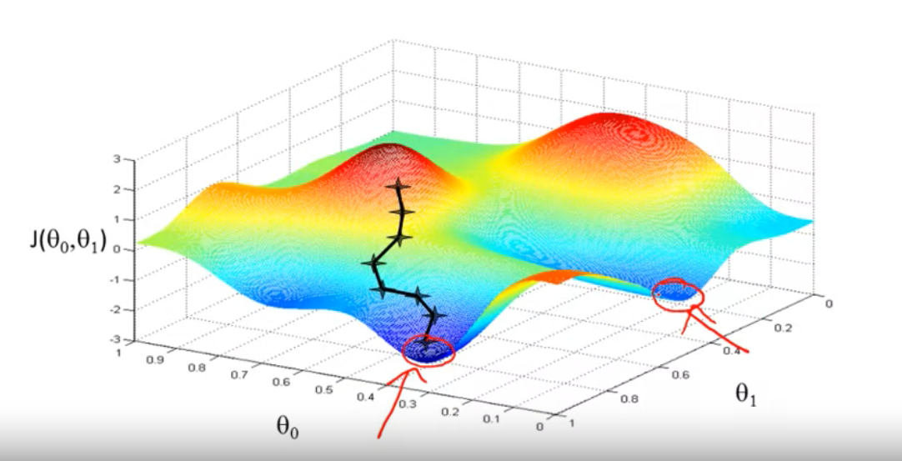



**Cost function (convex)**

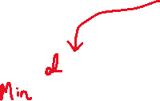

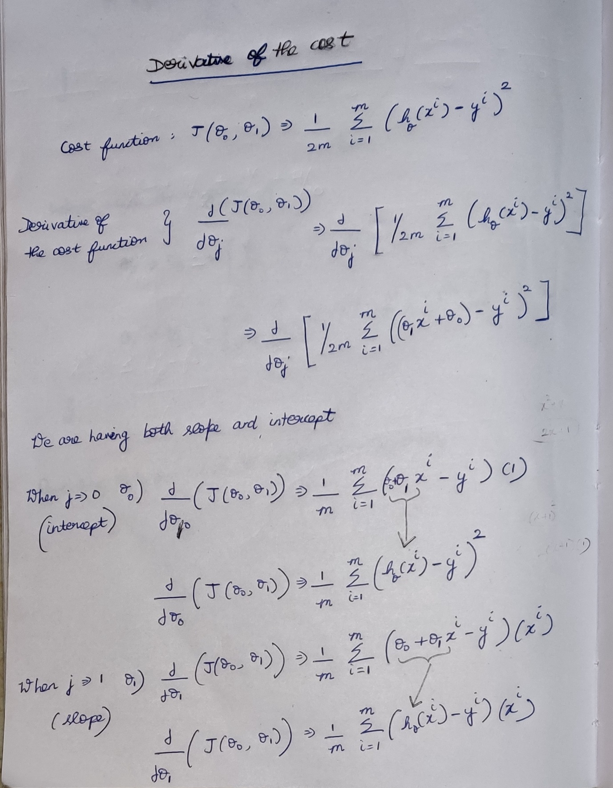

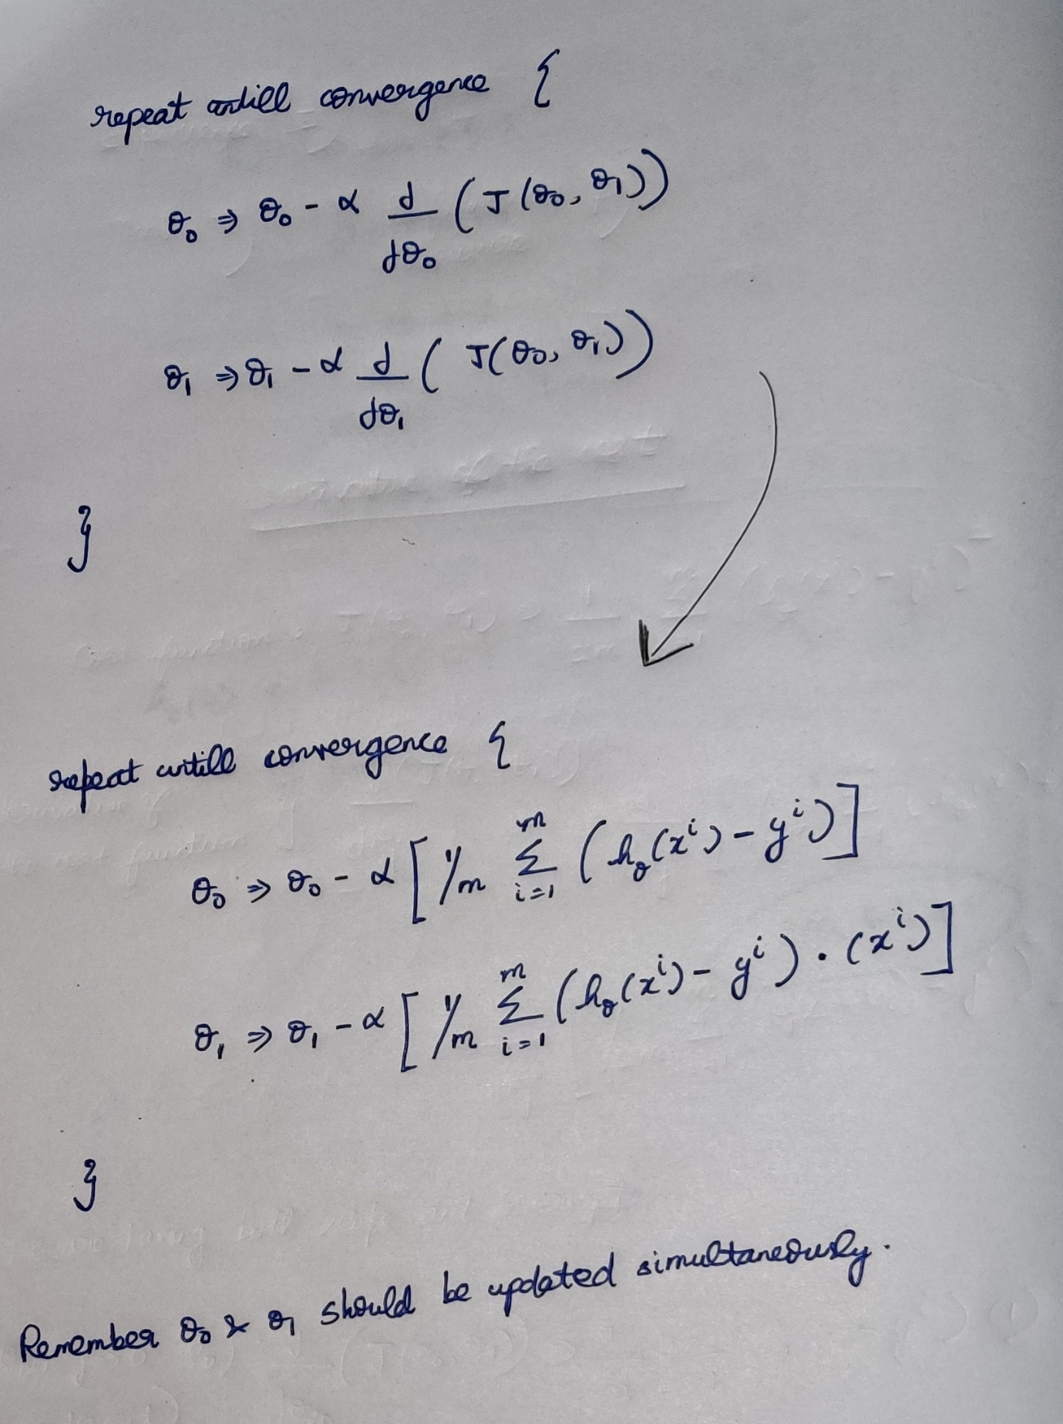

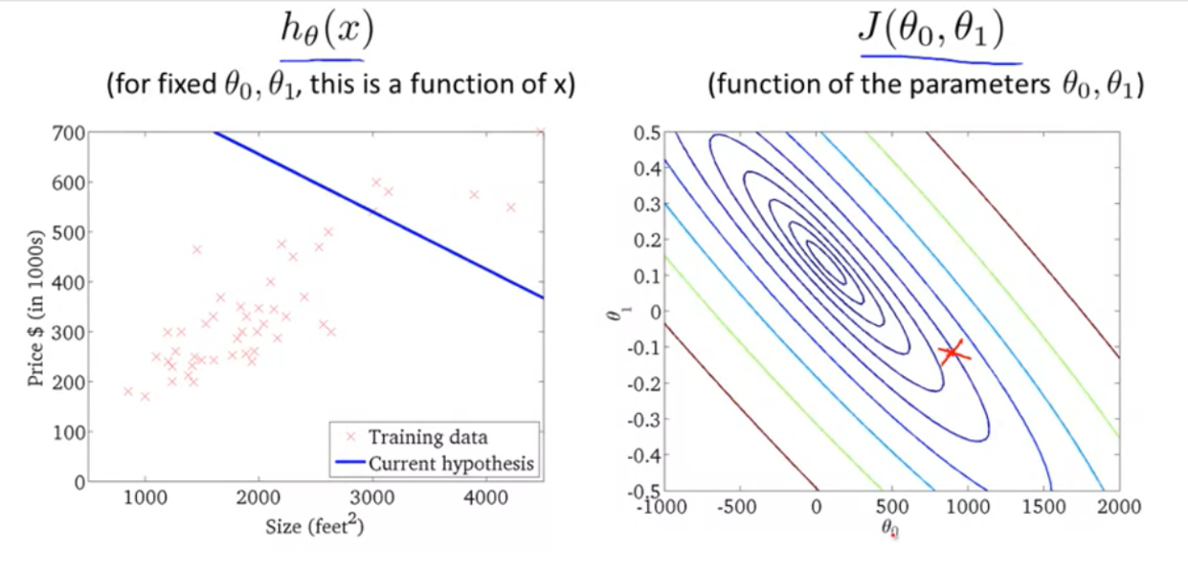

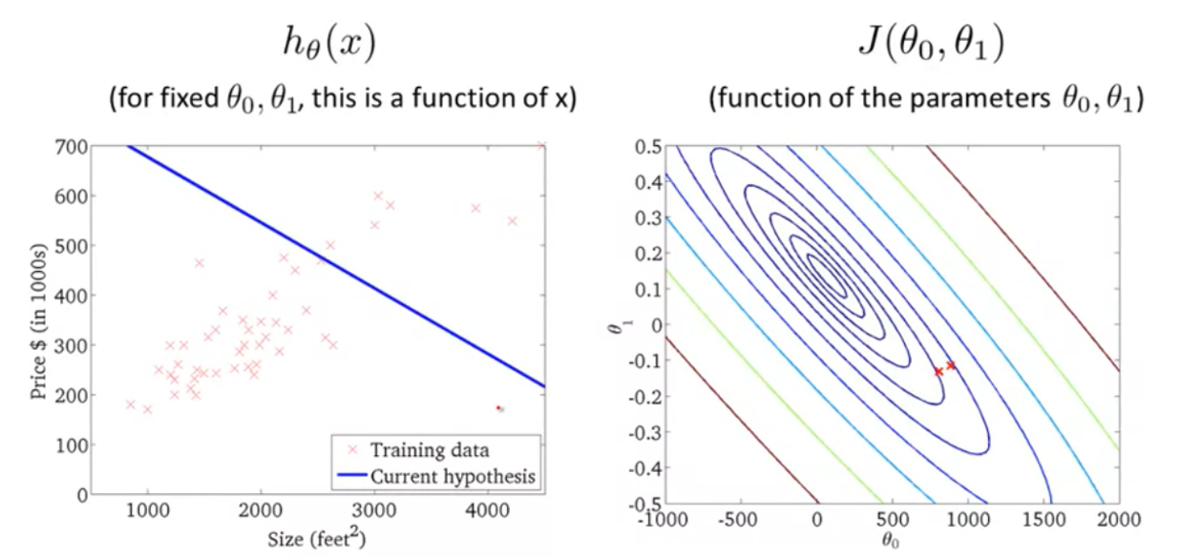

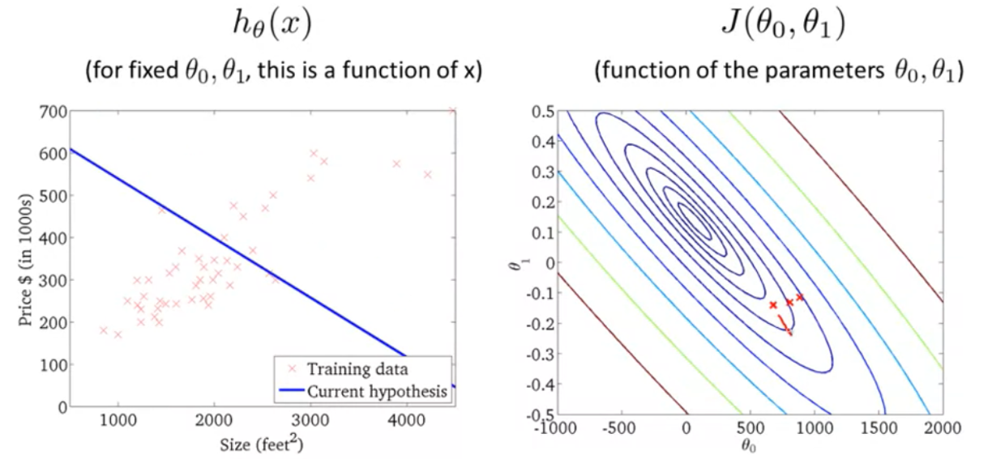

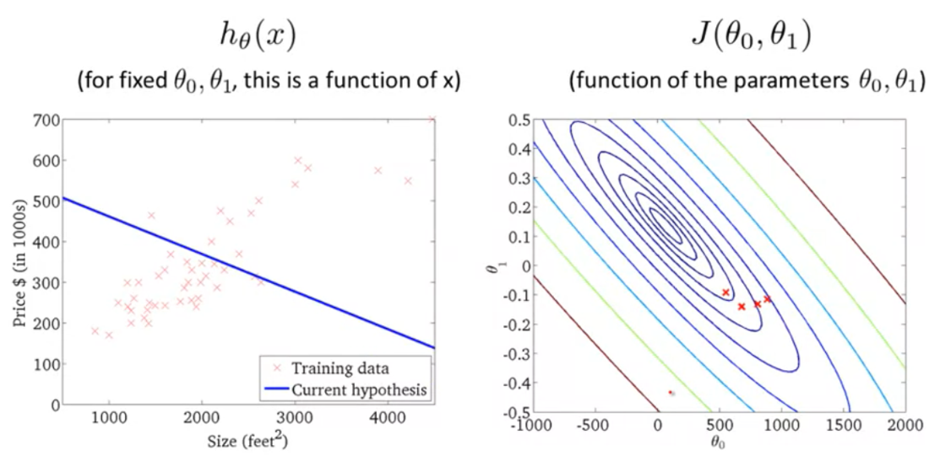

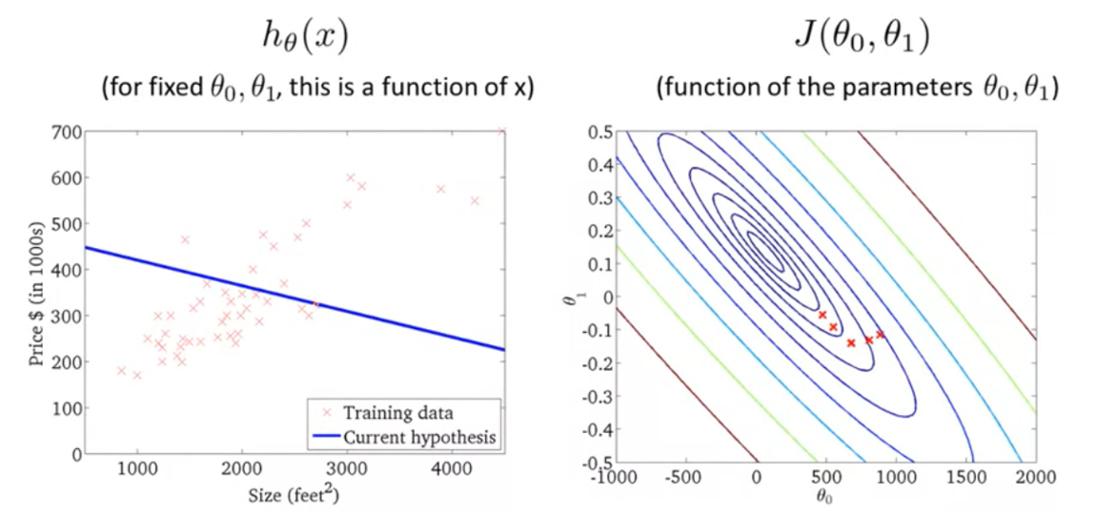

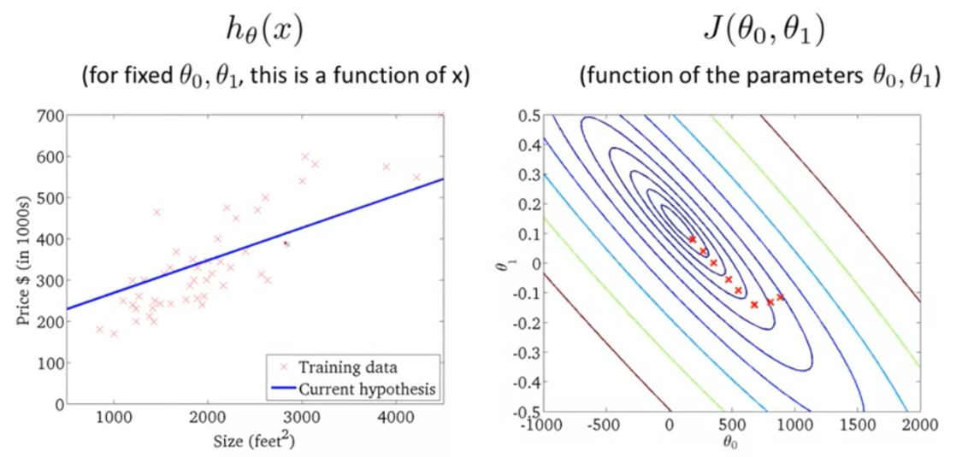

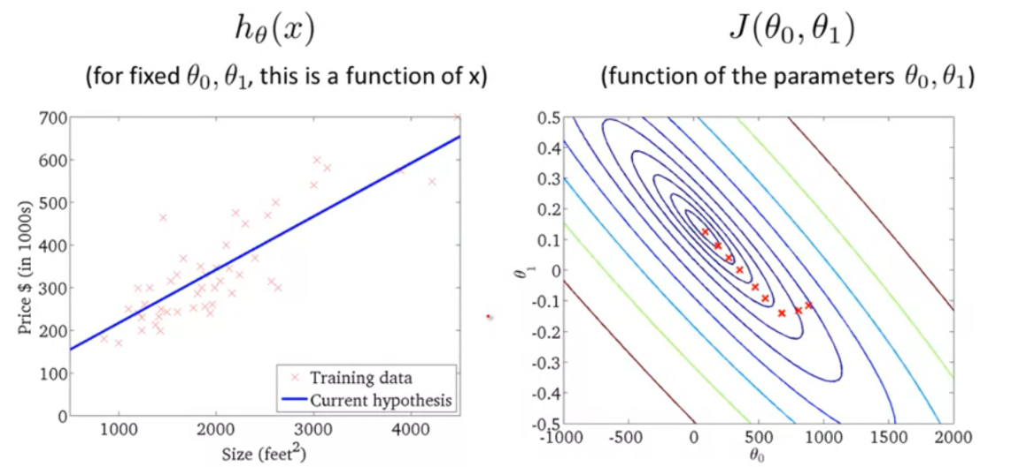

As the point approaches to the local minimum point in the cost function, the line in is more accurate and precise.



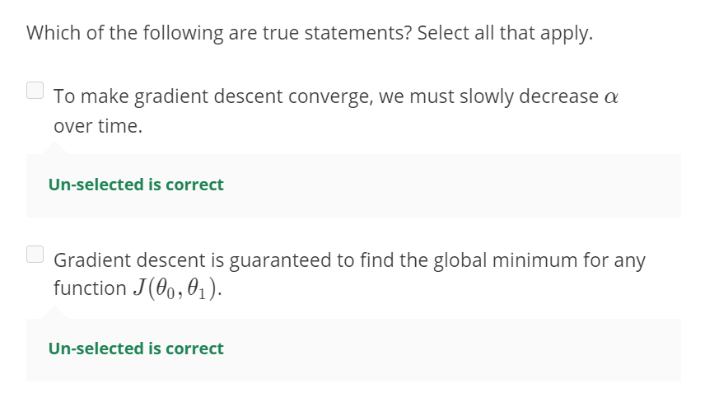

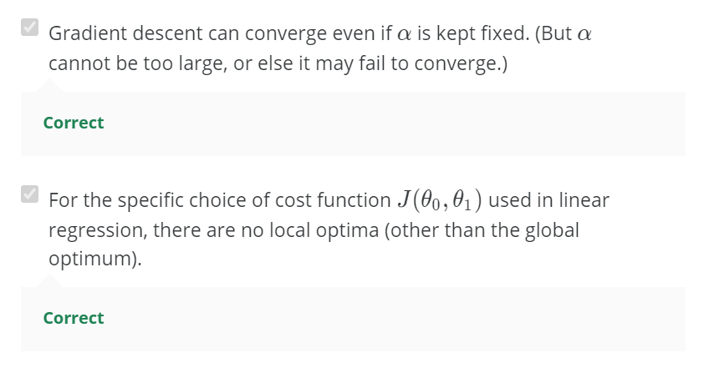

**Quiz:**

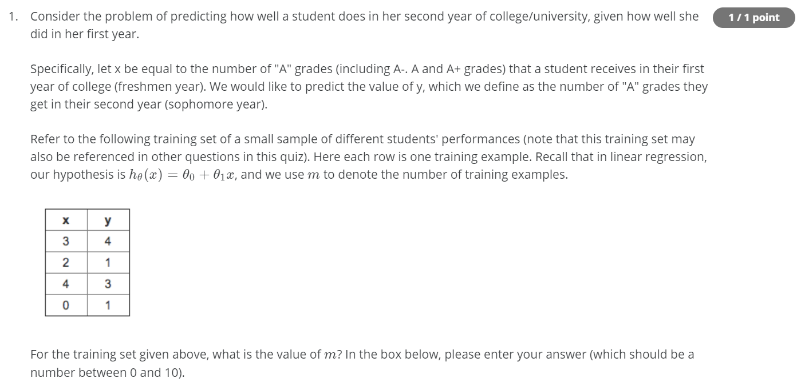

**Ans 🡪 4**

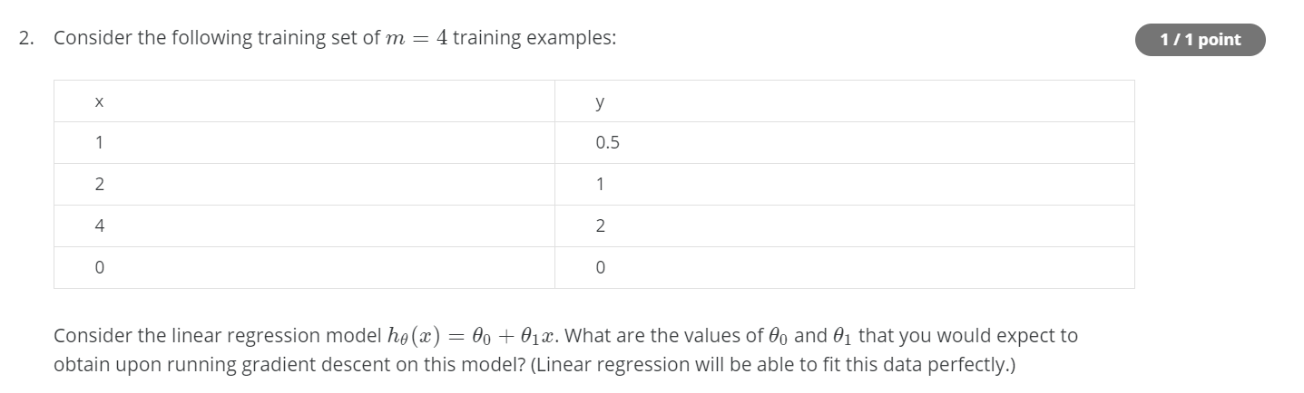

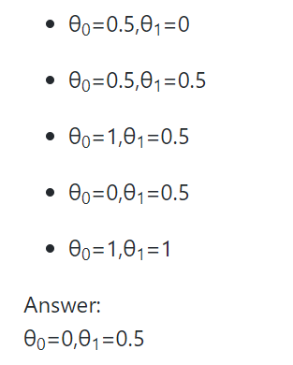



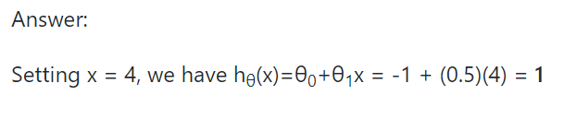

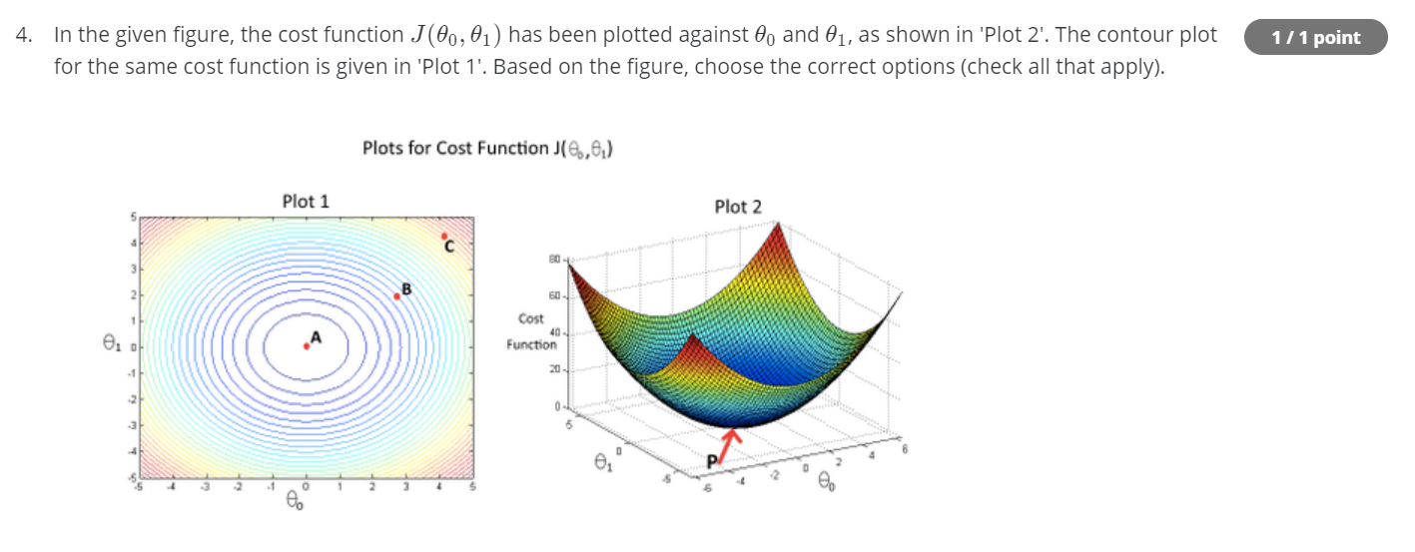

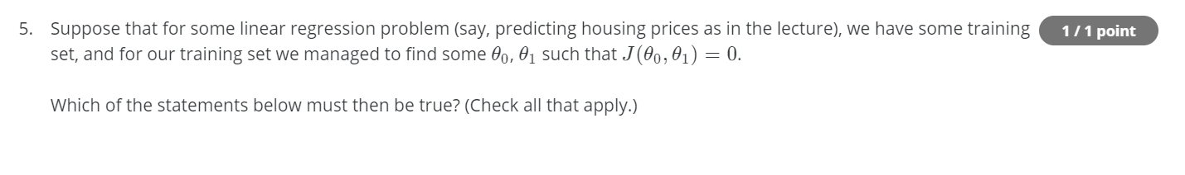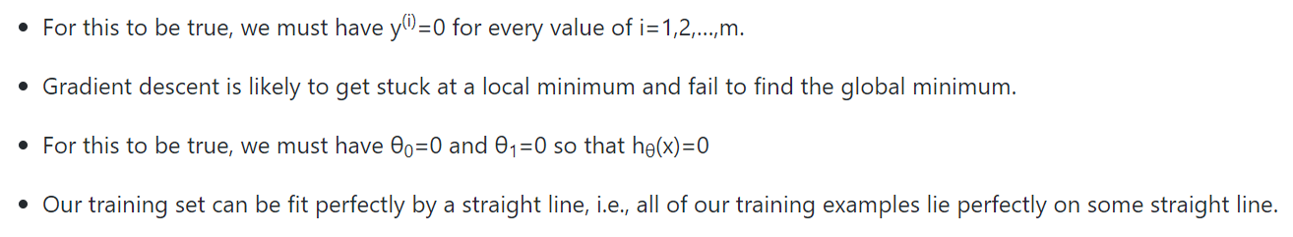

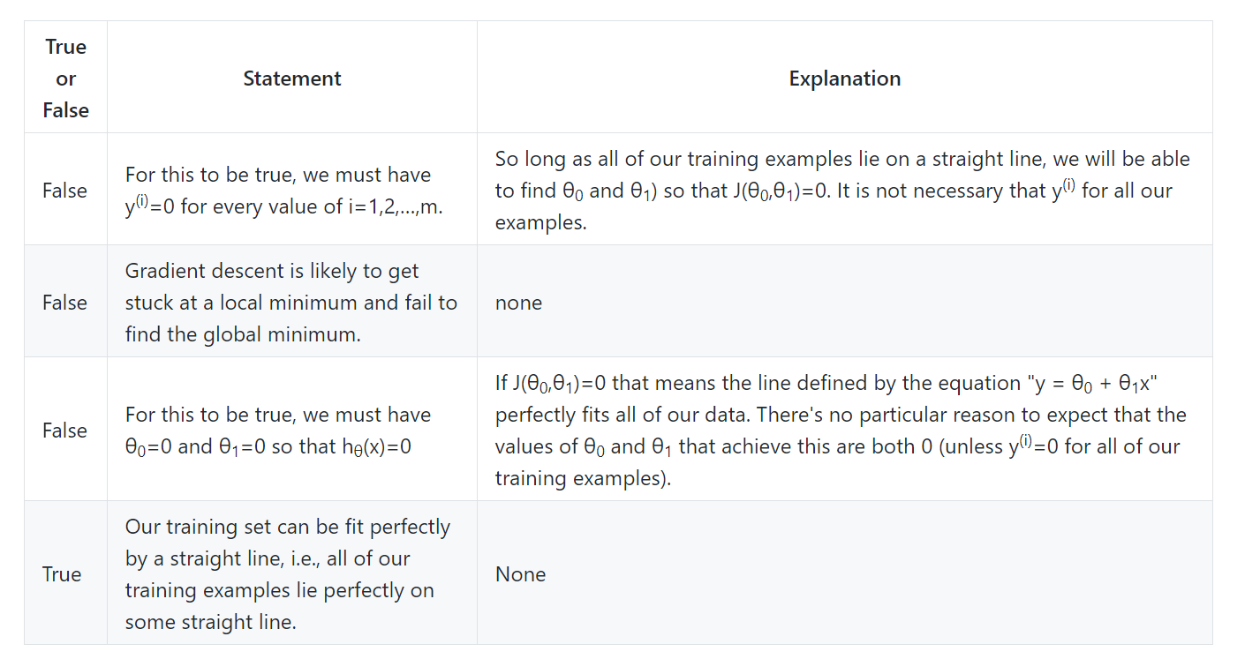

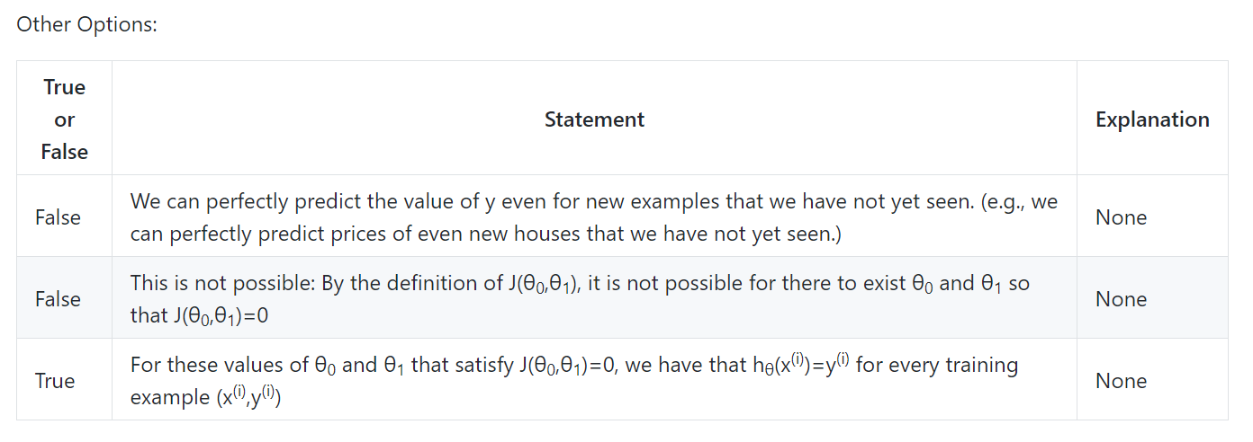

**Linear Algebra Review**

**Matrices and Vectors**

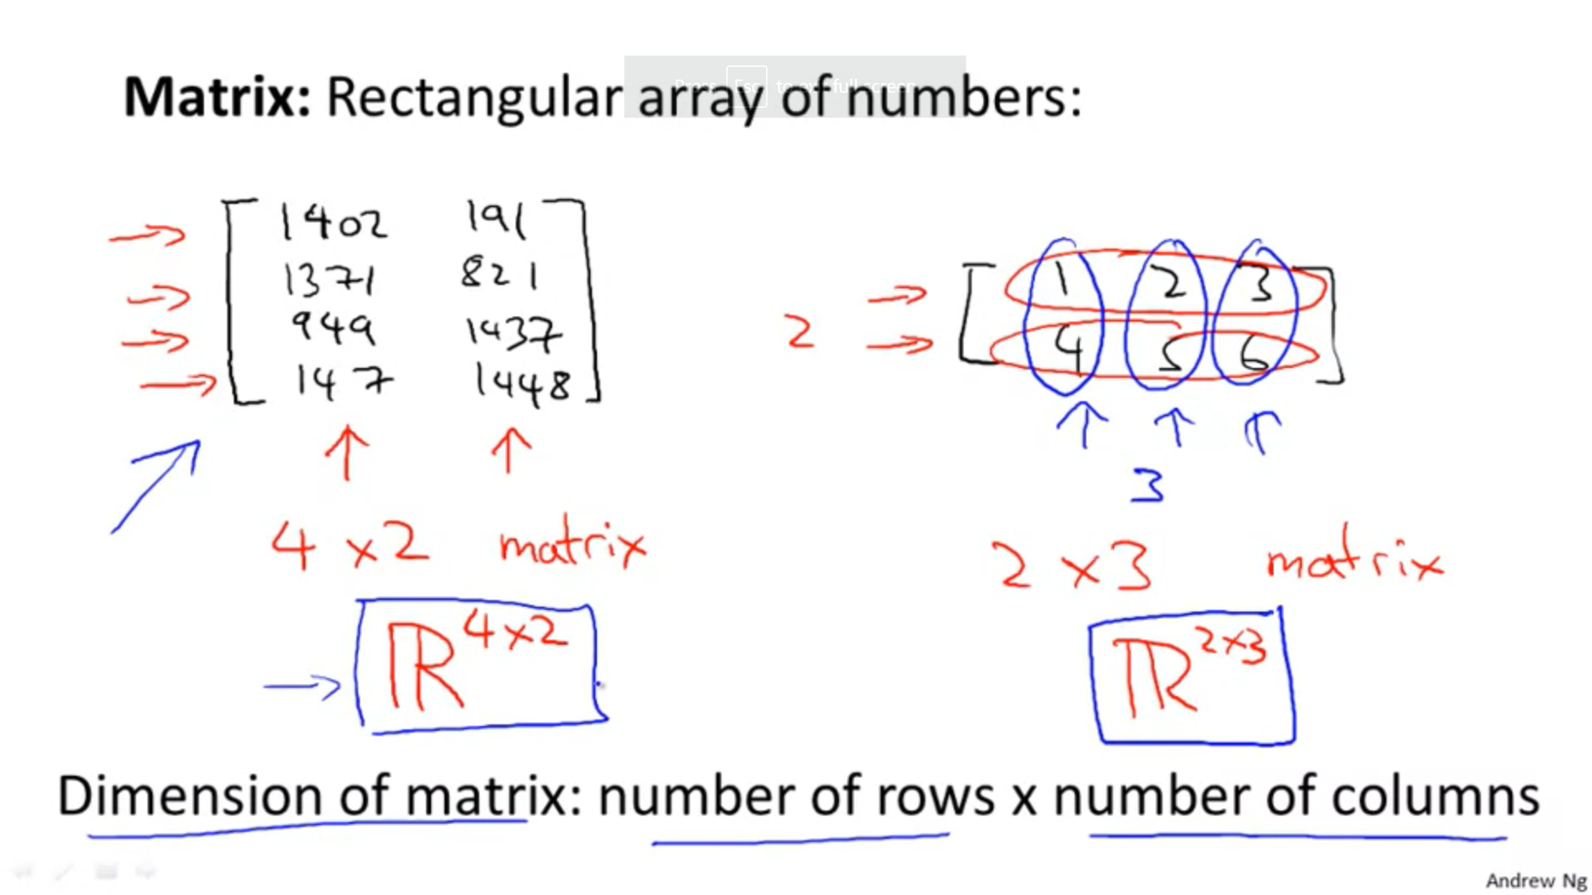

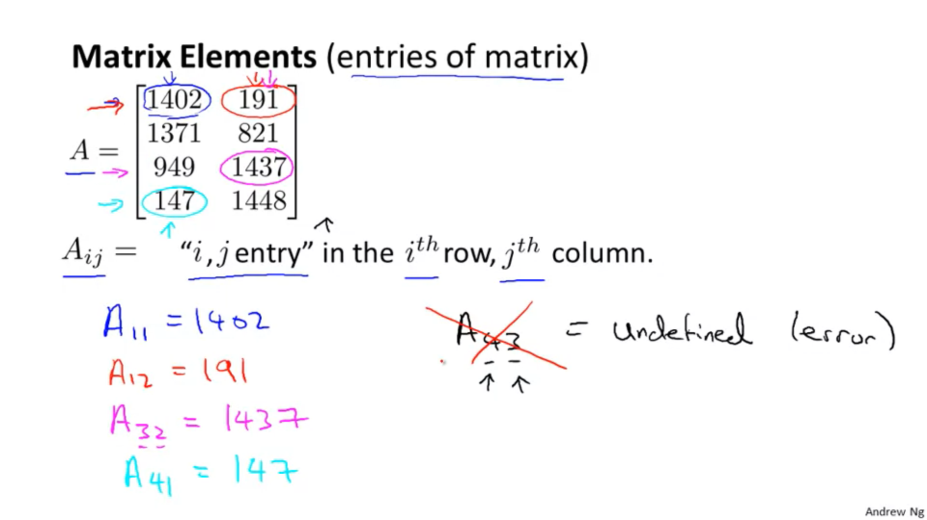

Vector 🡪 A matrix having only 1 column

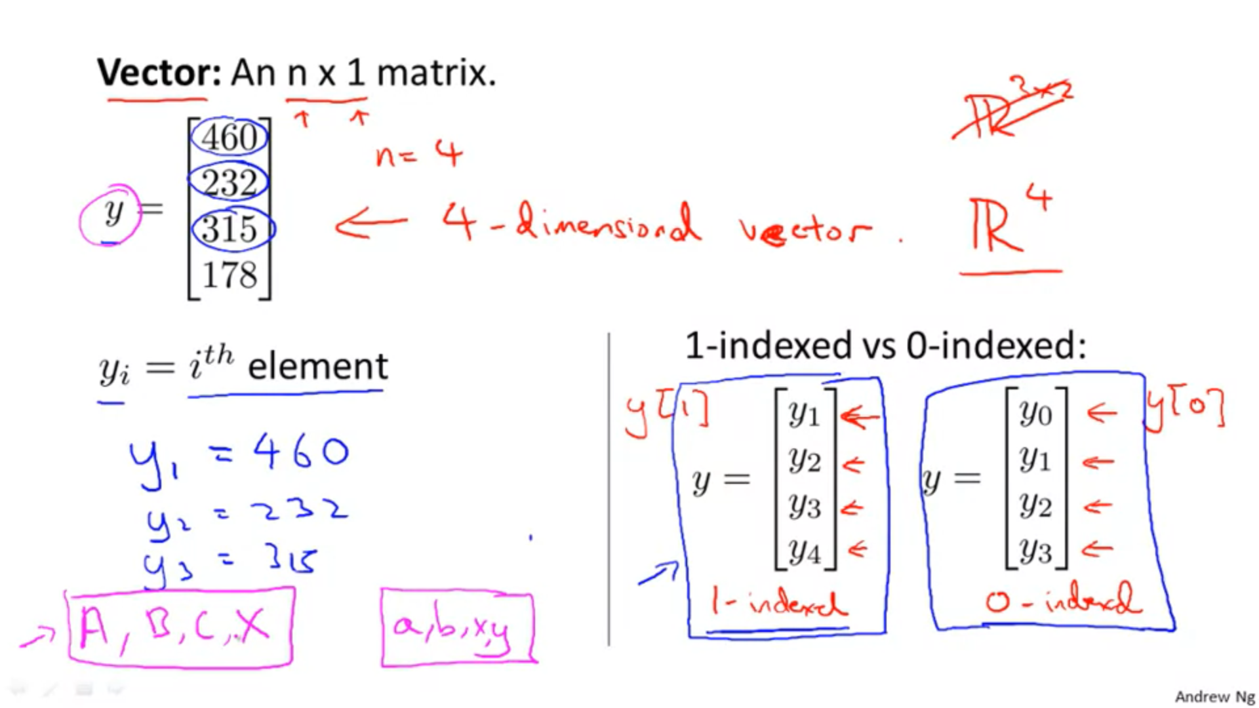



Matrix Vectors, scalars   
notation notation



**Matrix addition and scalar multiplication**

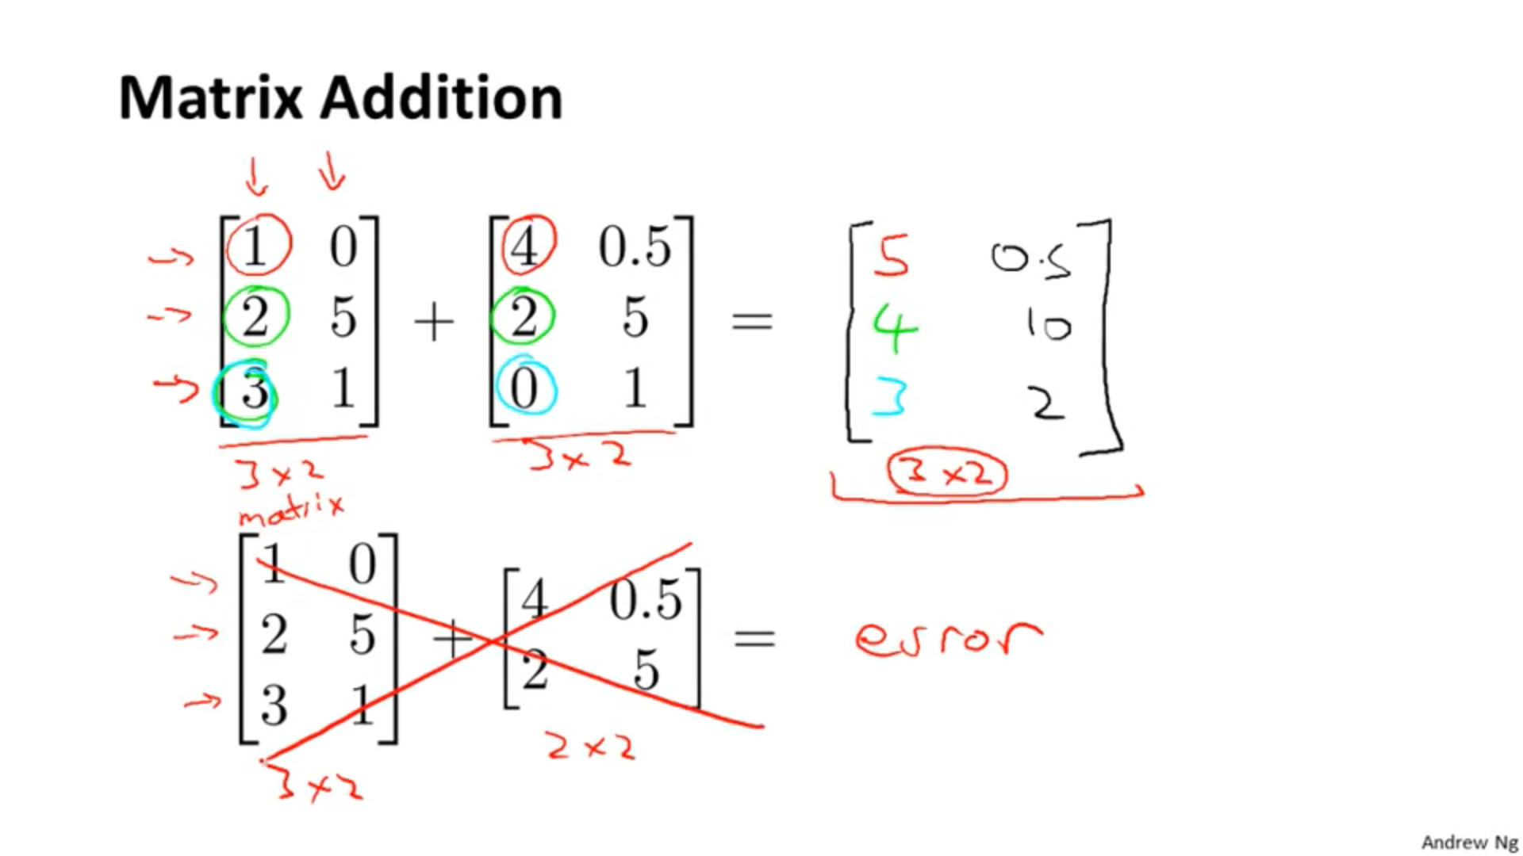

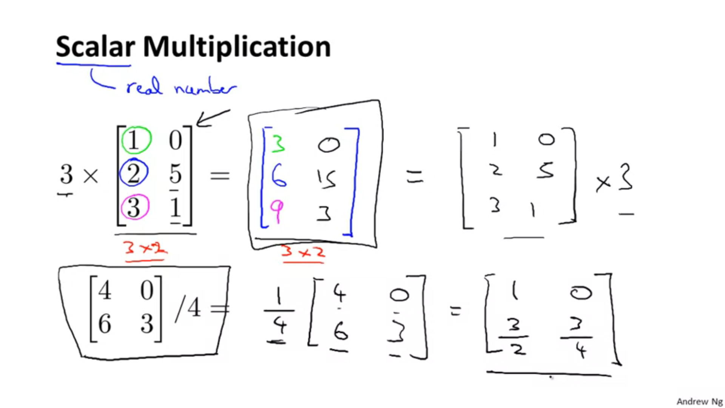

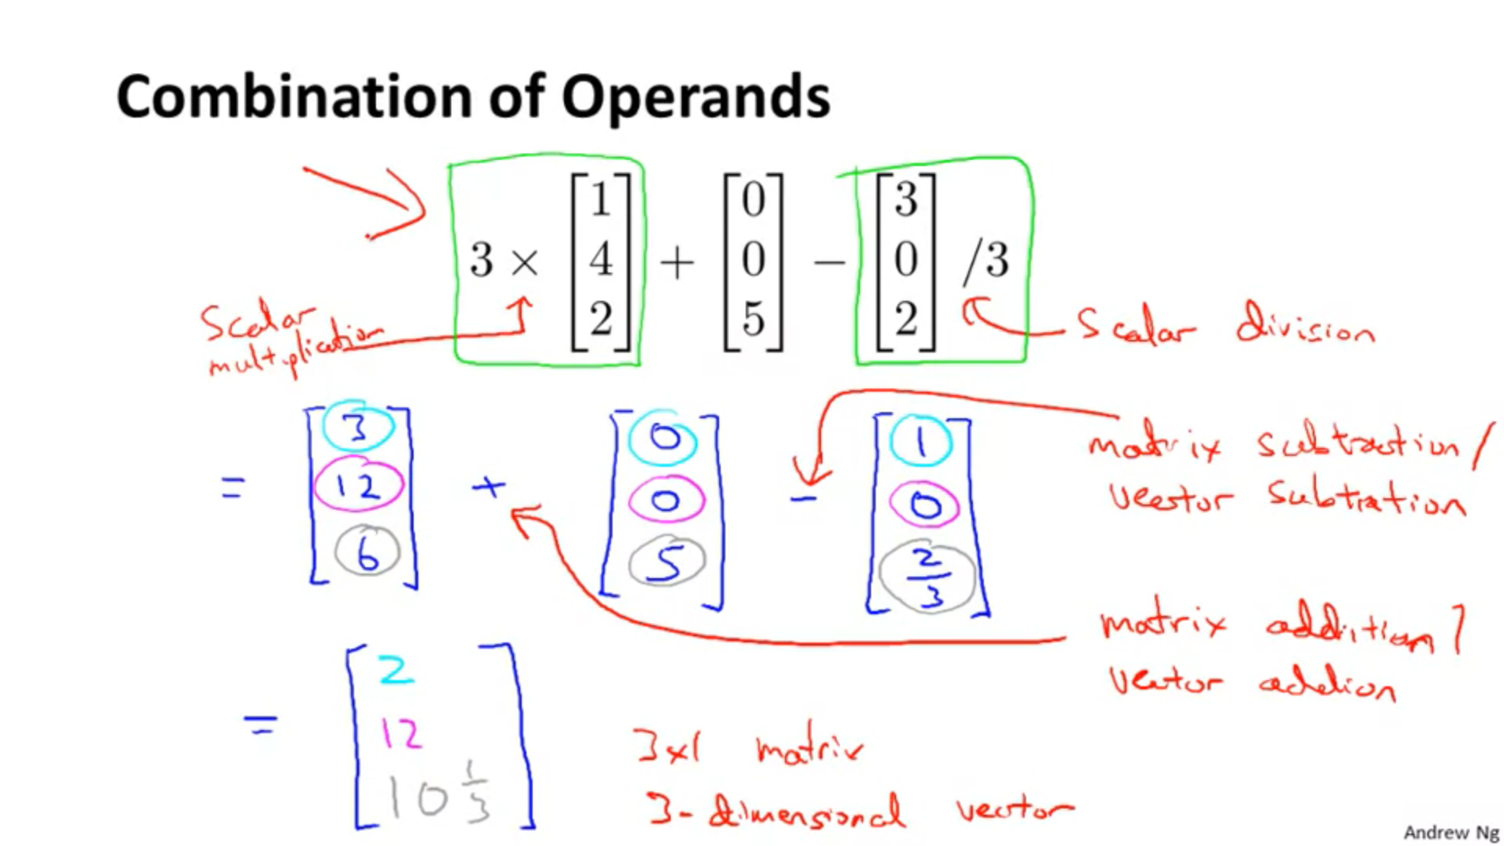

Do using BODMAS rule

**Matrix vector Multiplication**

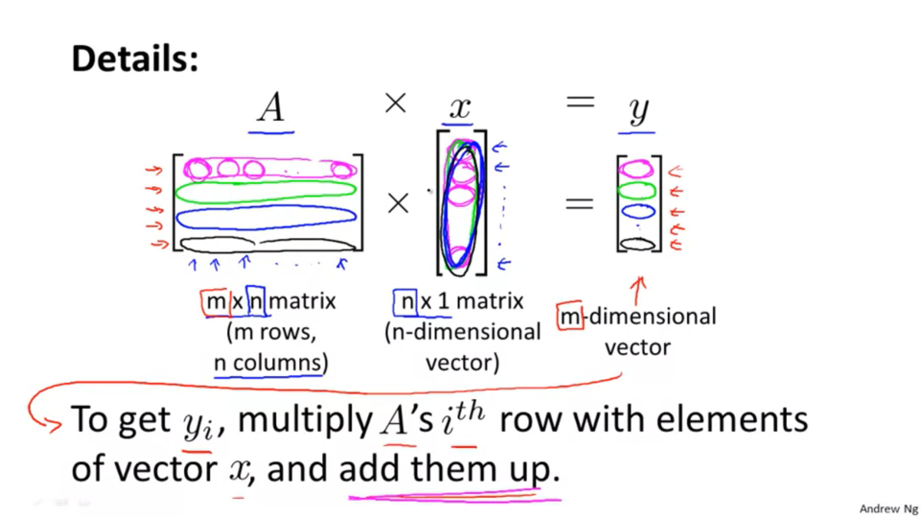

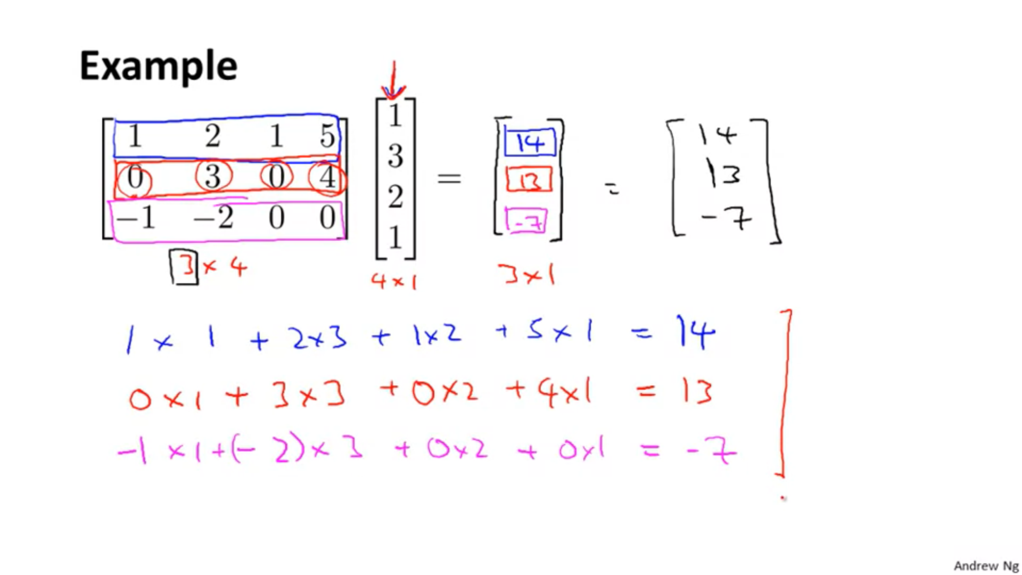

**Practical implementation:**



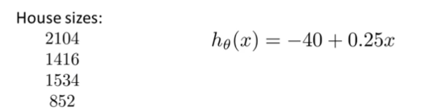



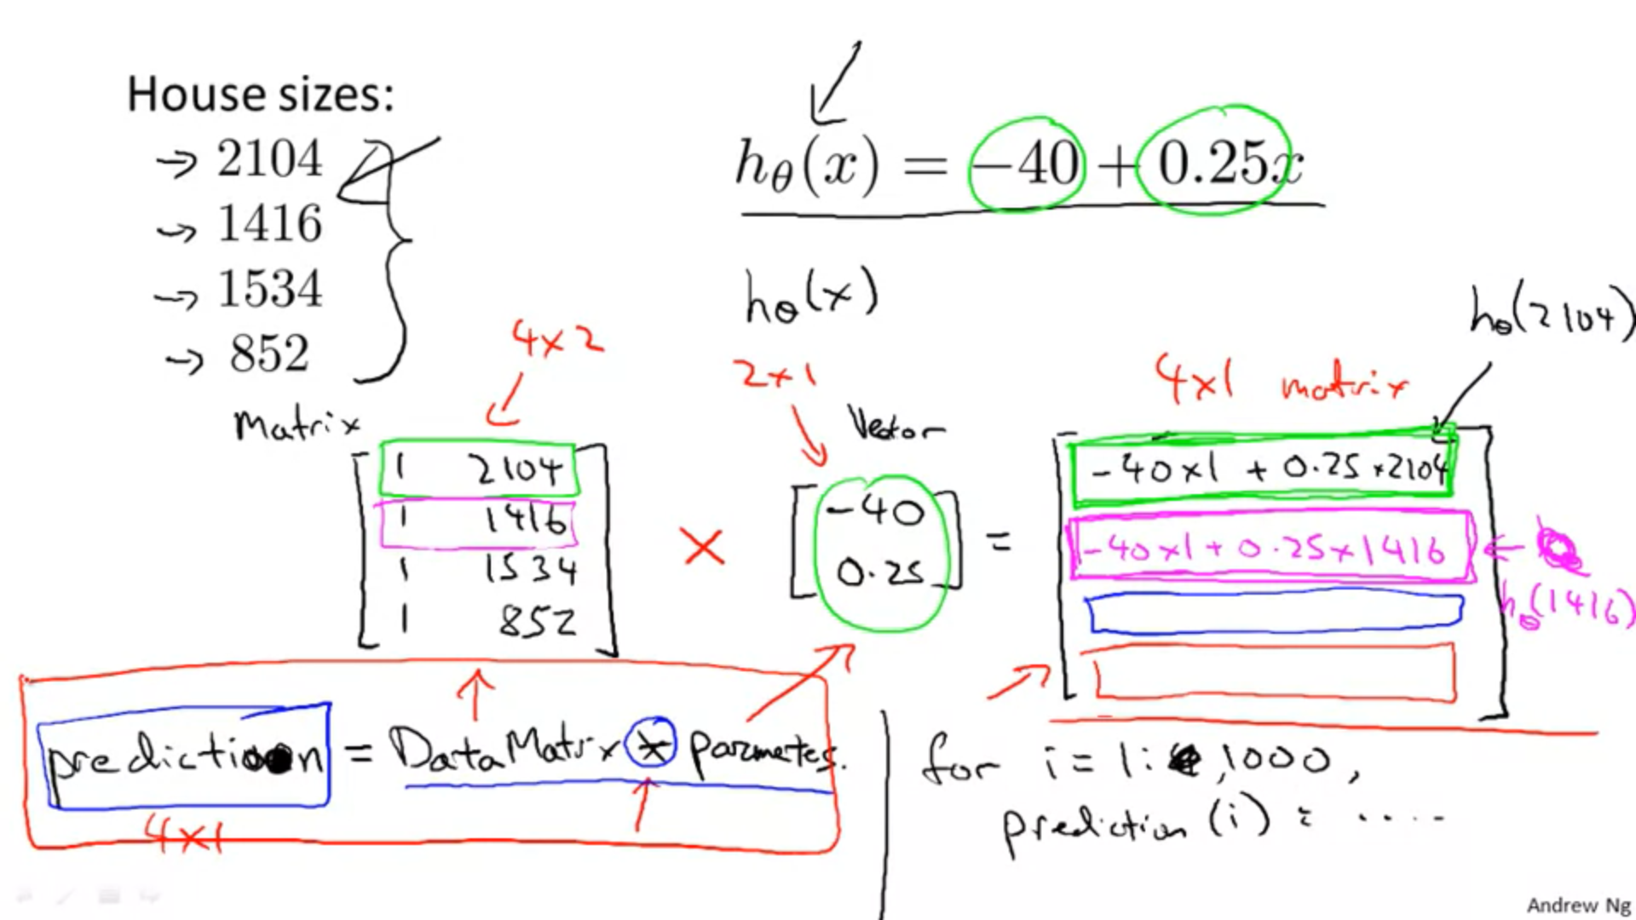

**Matrix-Matrix multiplication**

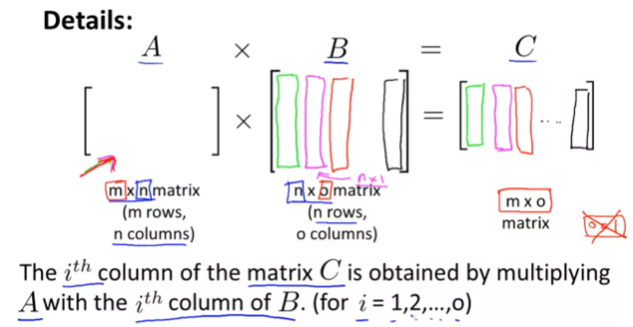

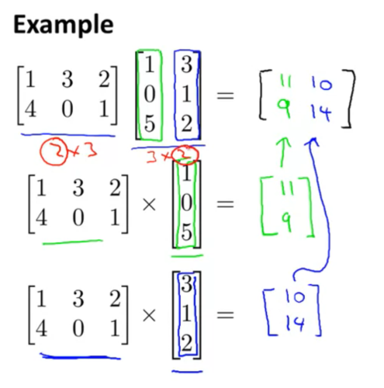

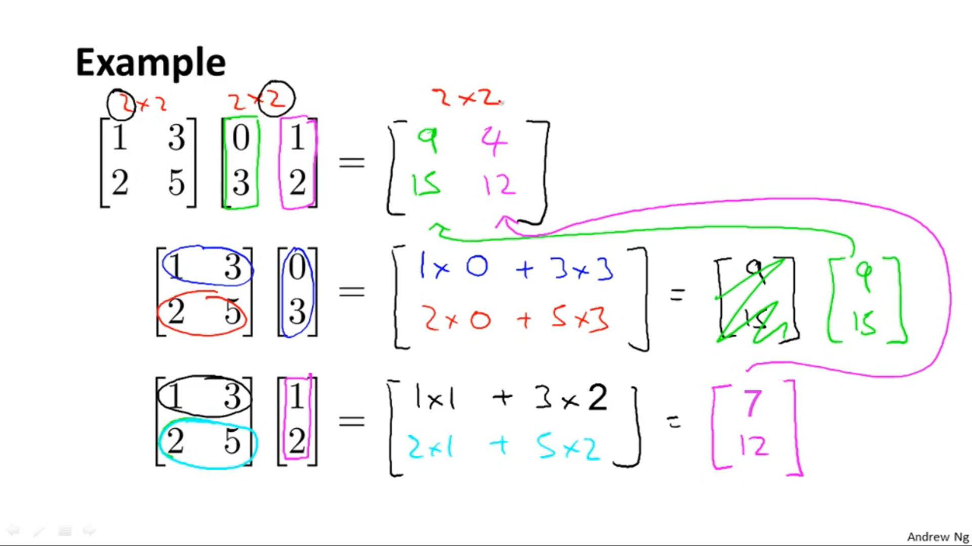

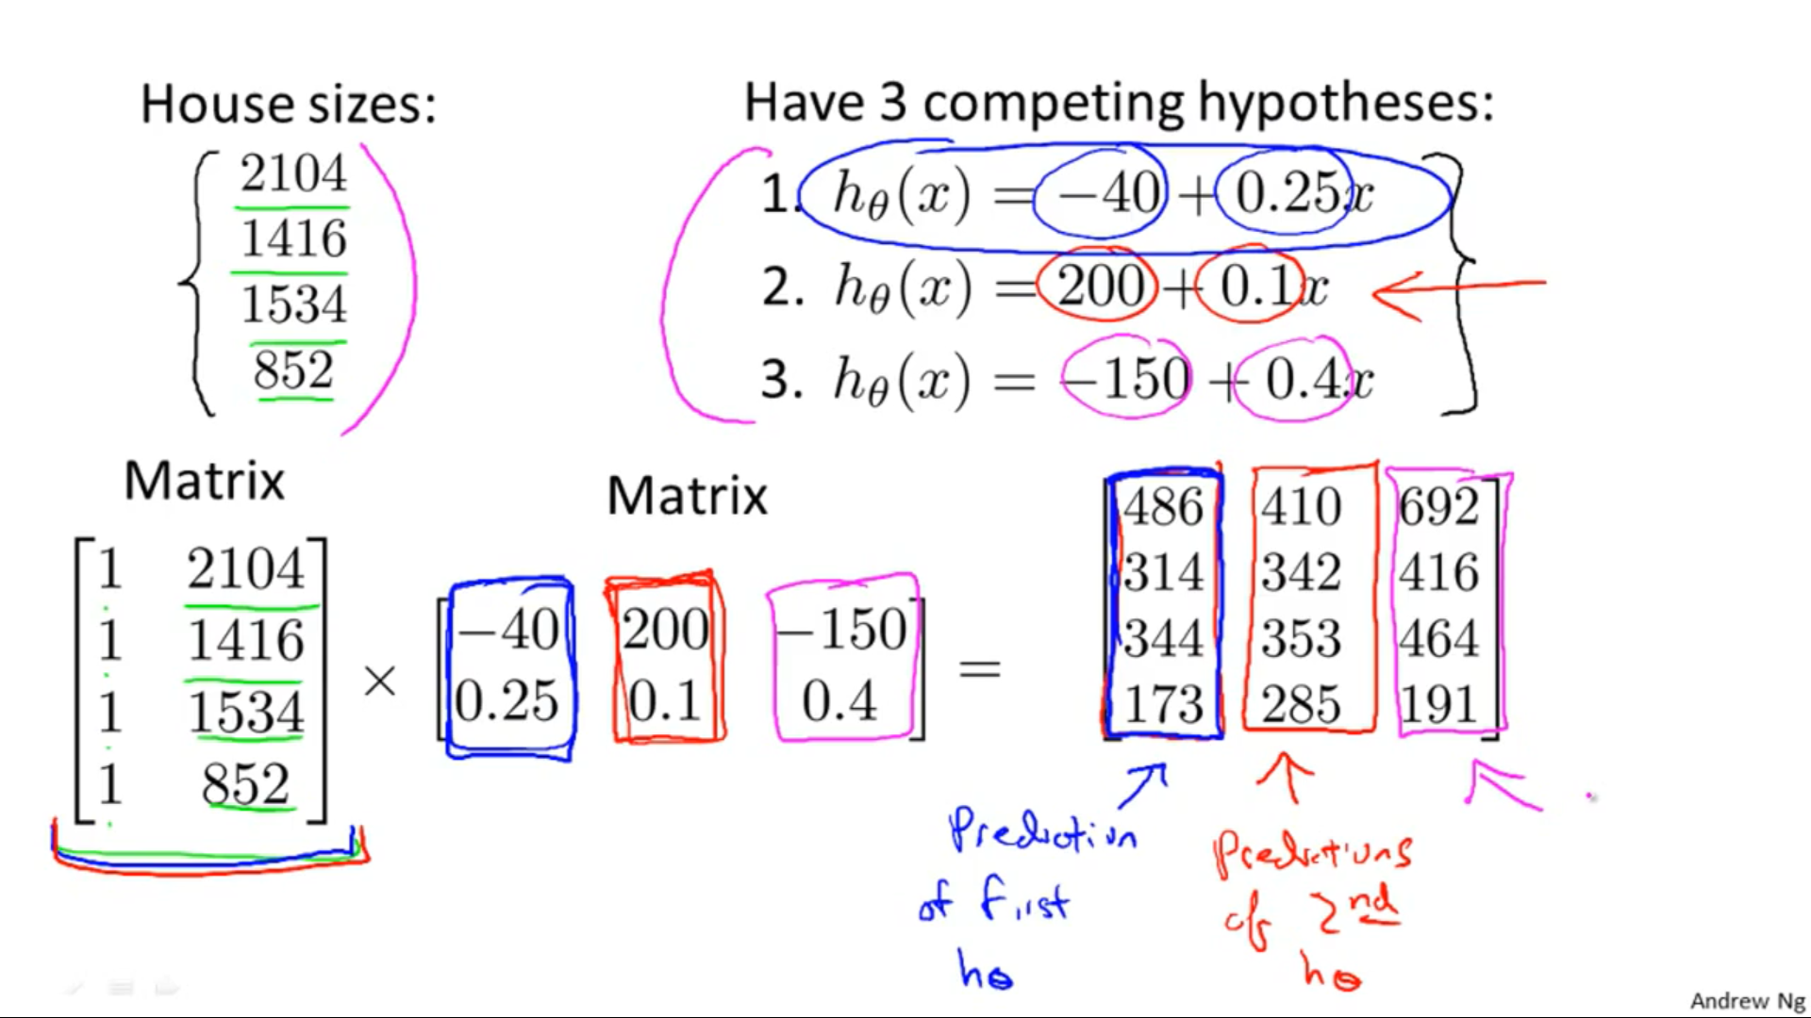

**Properties of Matrix:**

1) Matrix multiplication is not commutative

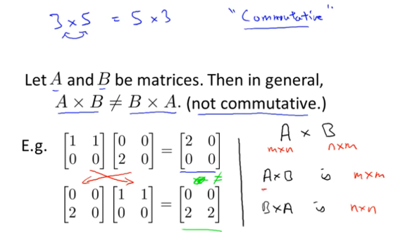

2) Matrix multiplication is always associative

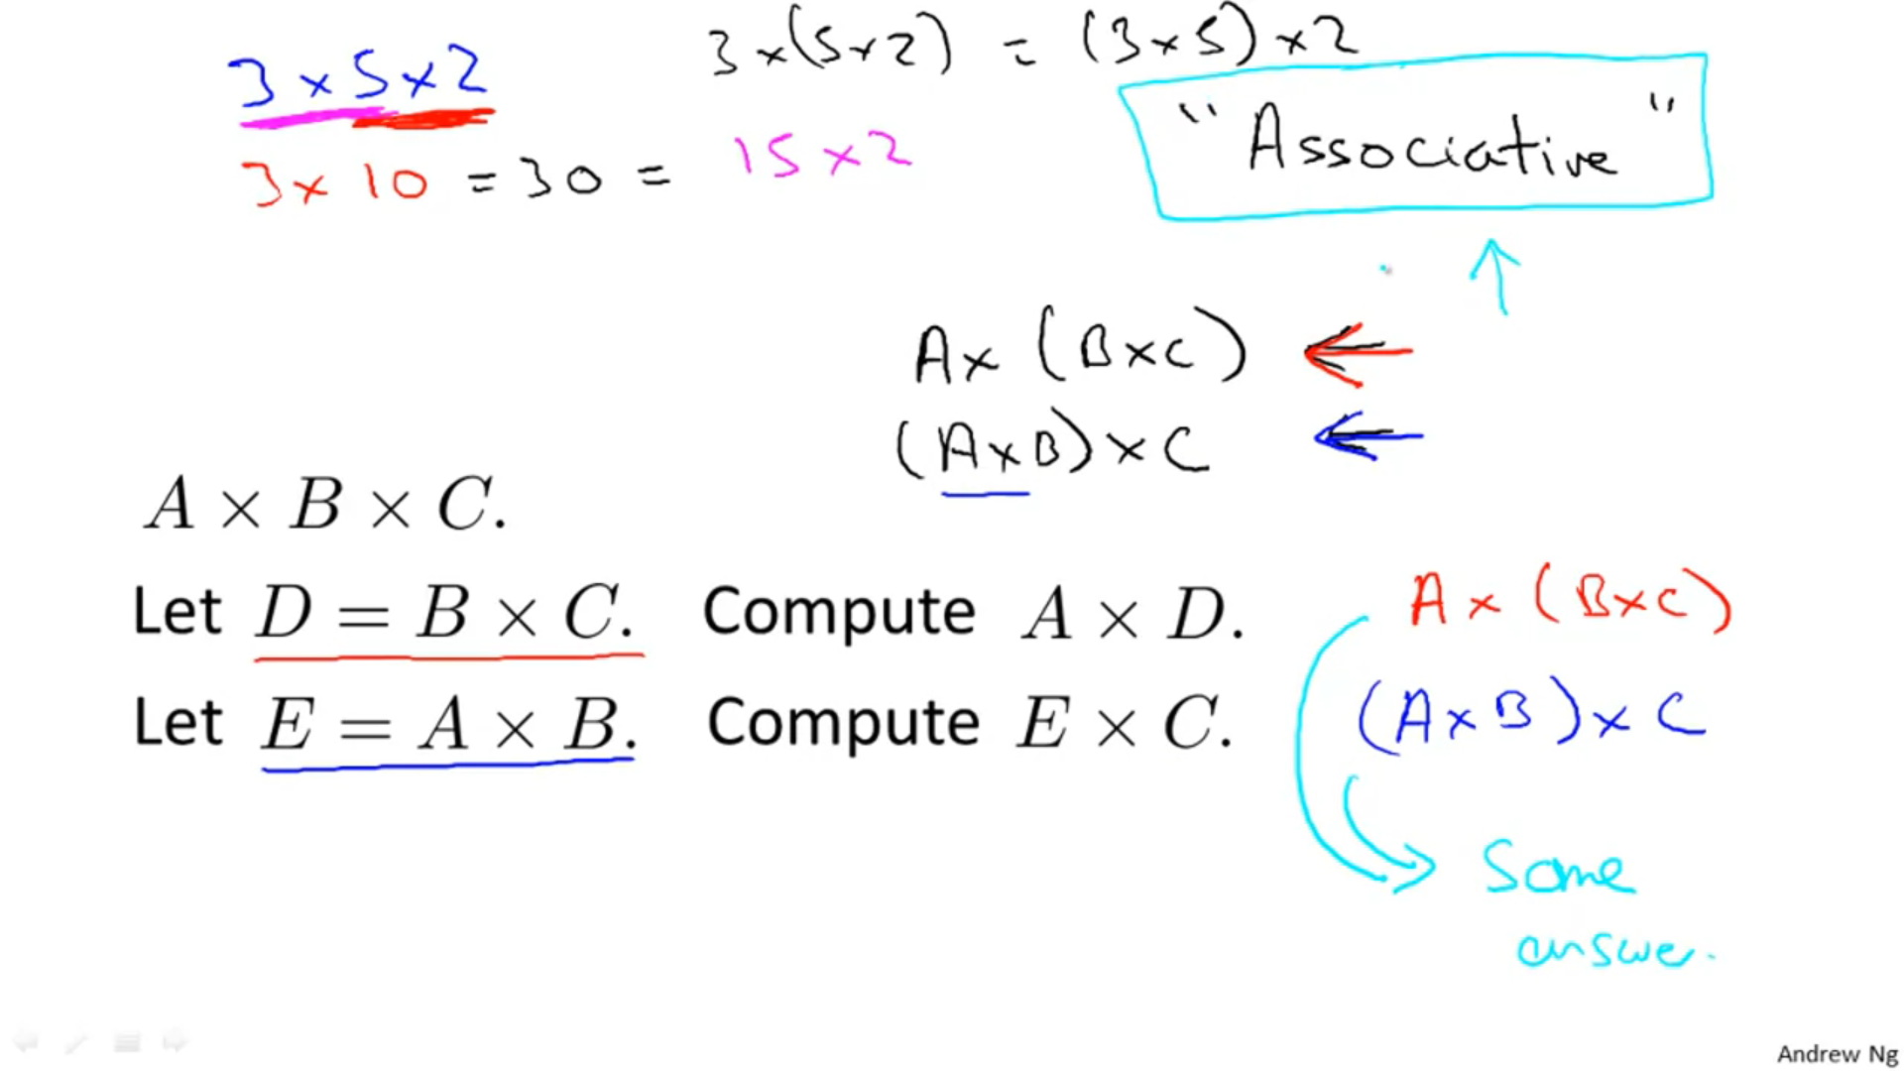

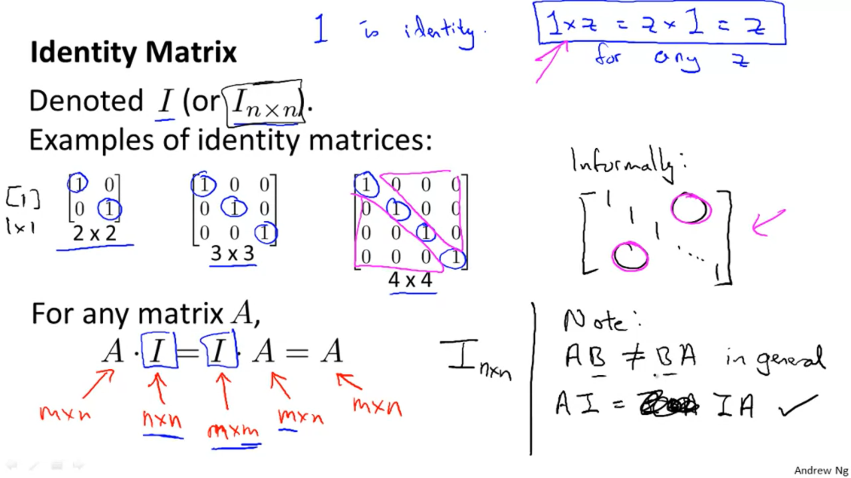



**Inverse and Transpose**

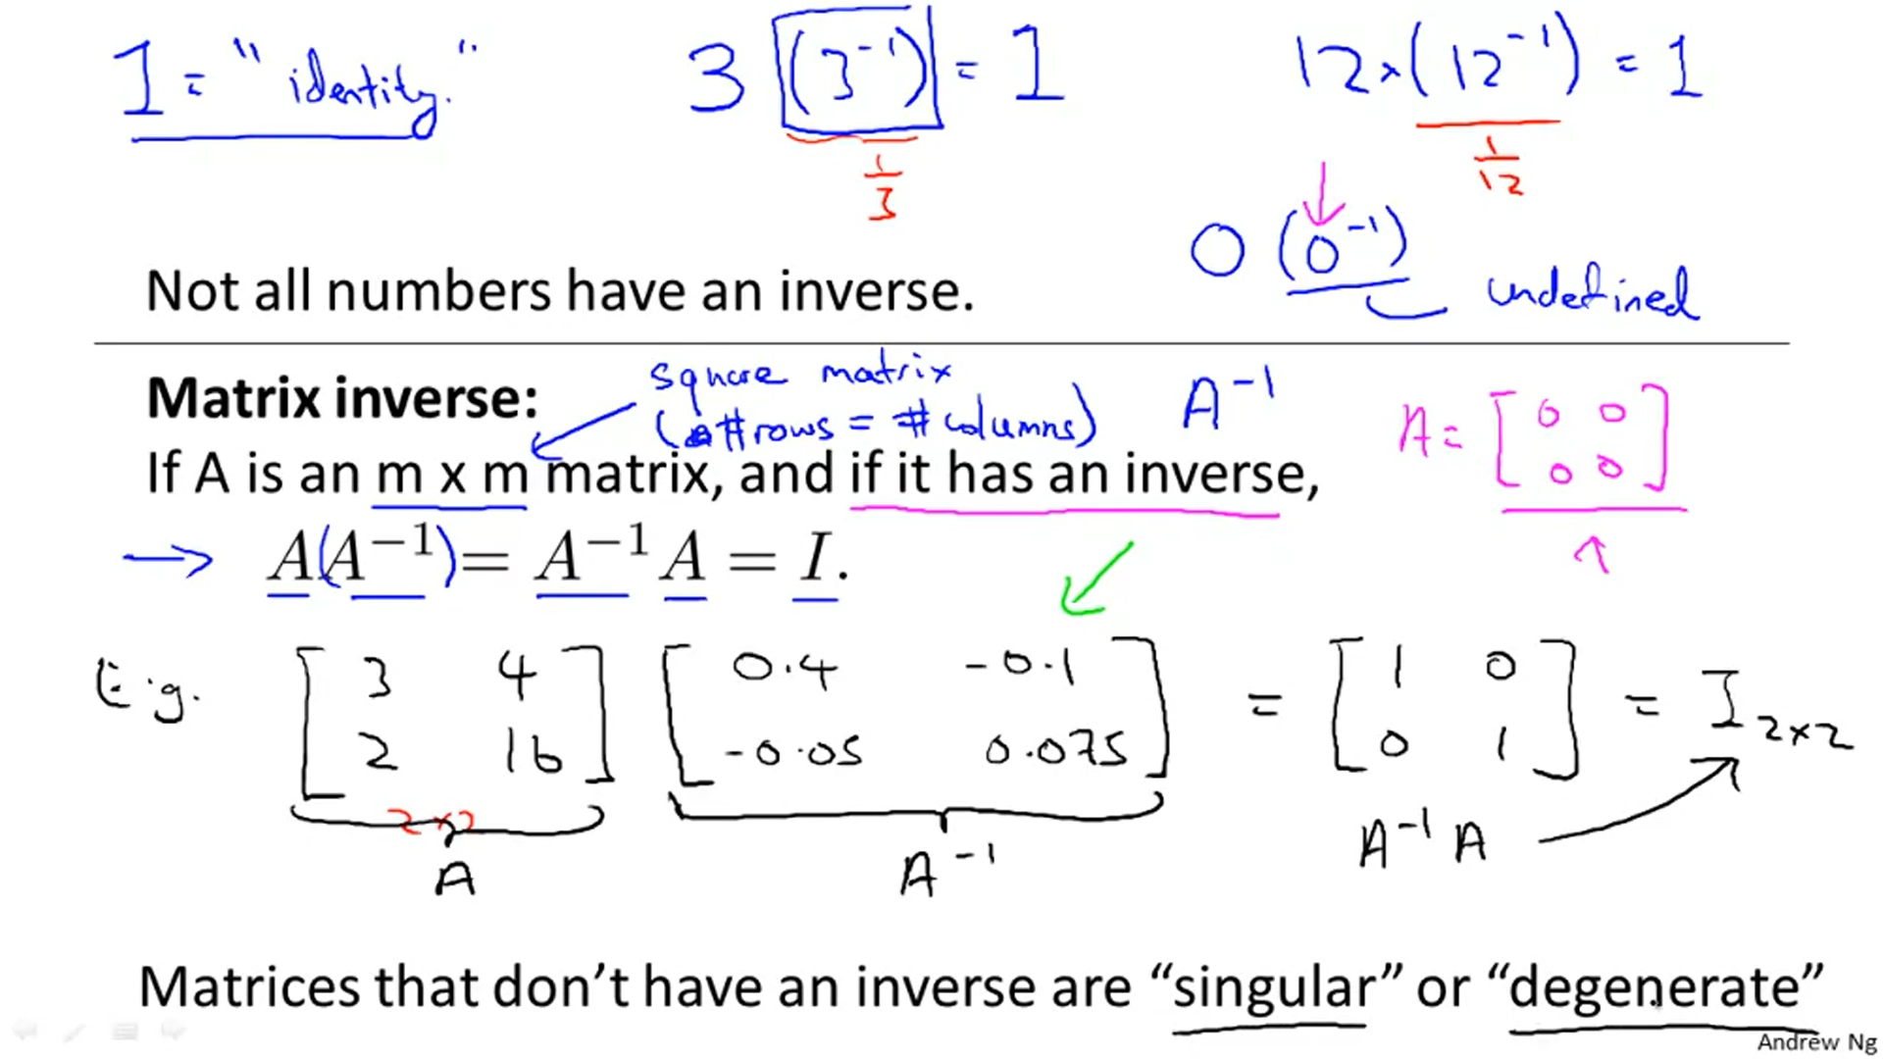

0 doesn’t have inverse, in the same way A = [0,0 ; 0,0] (i.e matrix with all the elements 0) also doesn’t have inverse.

Matrices having inverses 🡪 Non-Singular matrix  
Matrices having no inverses 🡪 Singular matrix/degenerate

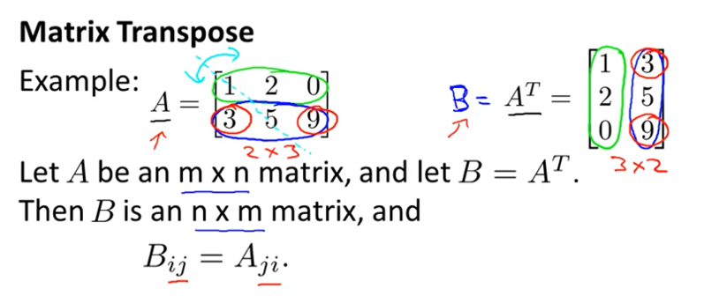  
 B = A = 9



B = A = 2



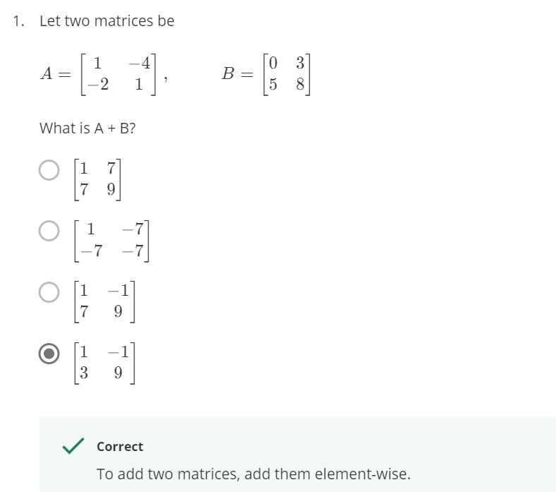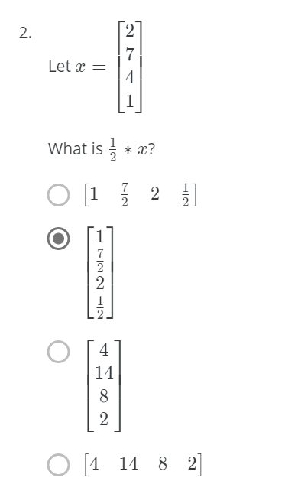

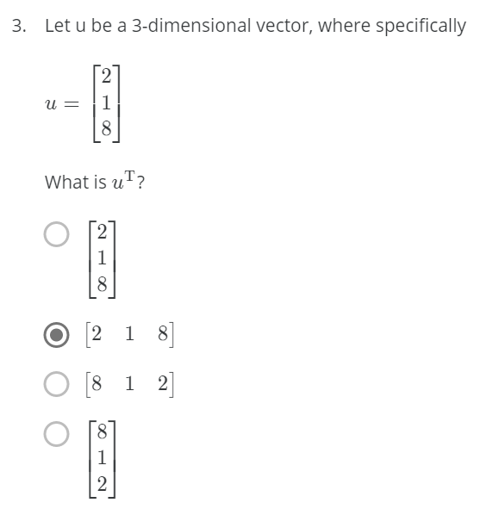

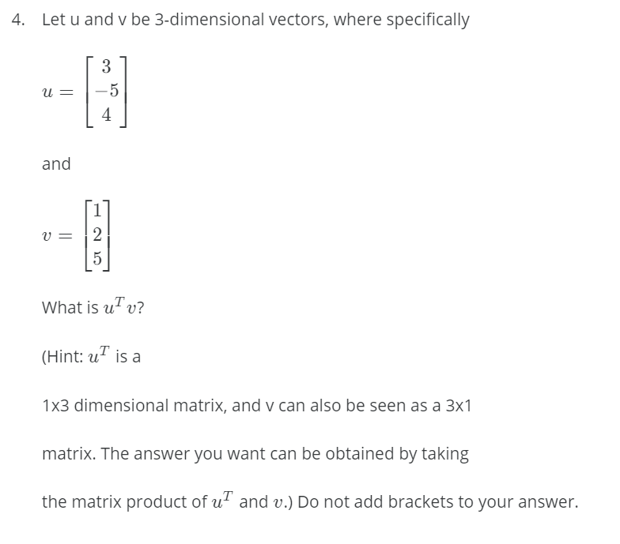

Ans 🡪 13

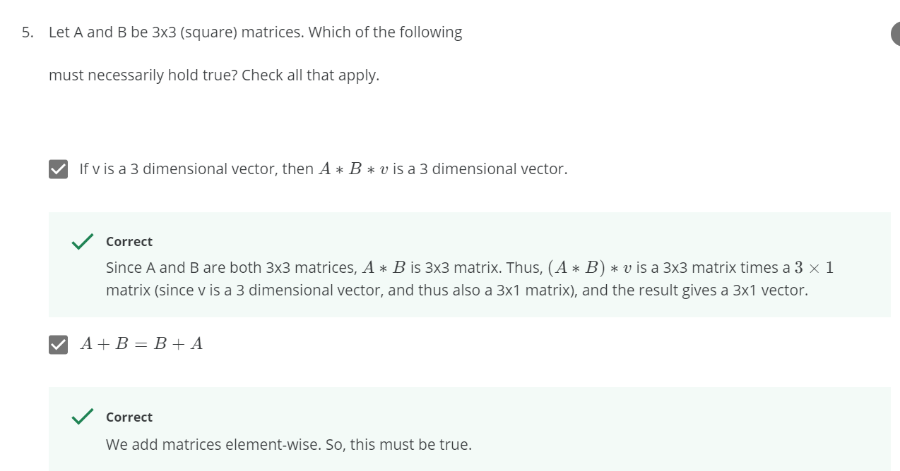  
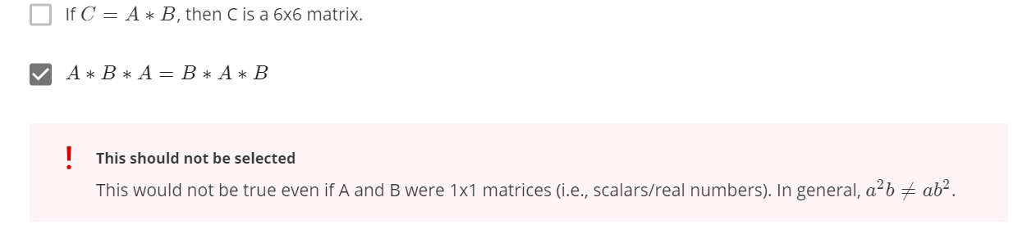

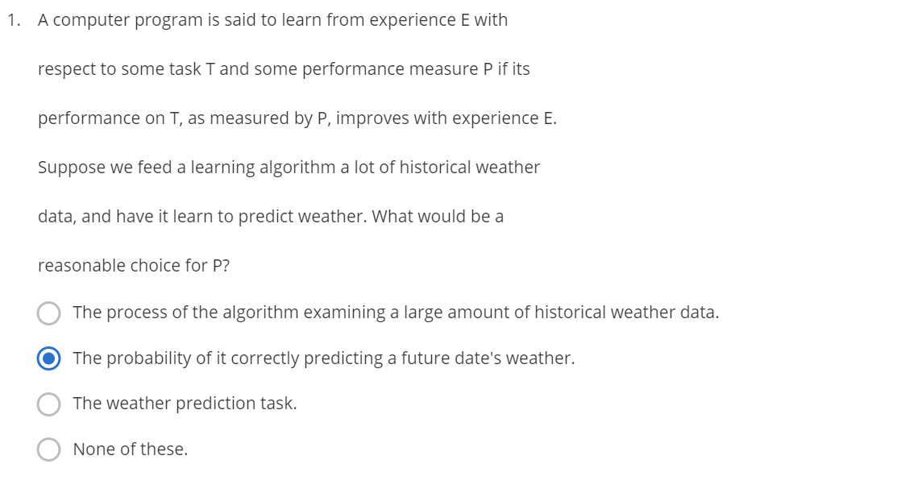



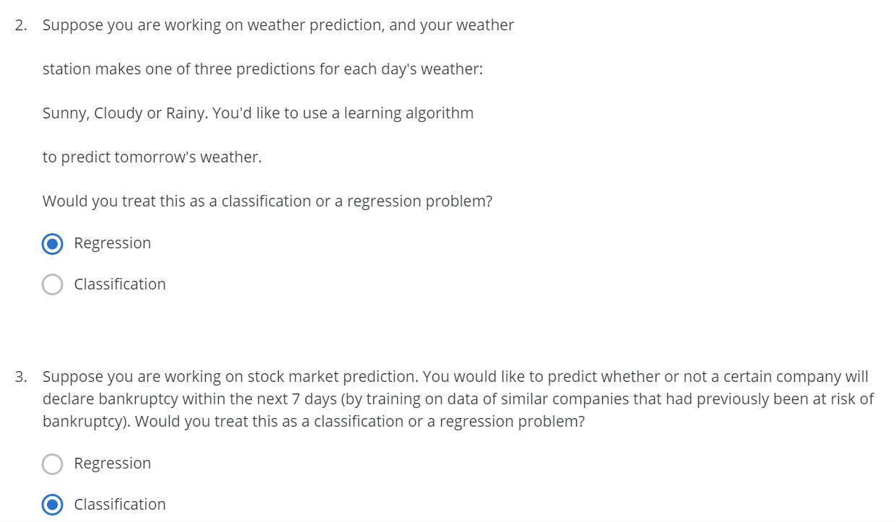



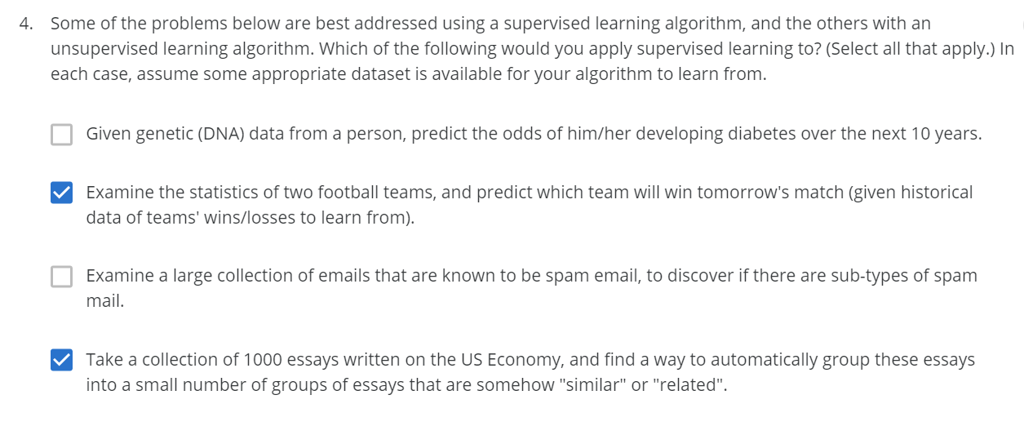

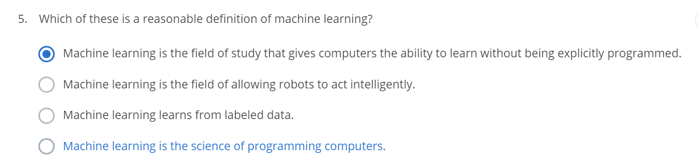



Locally weighed Linear regression

Implementation  
<https://xavierbourretsicotte.github.io/loess.html>

<https://www.geeksforgeeks.org/implementation-of-locally-weighted-linear-regression/>

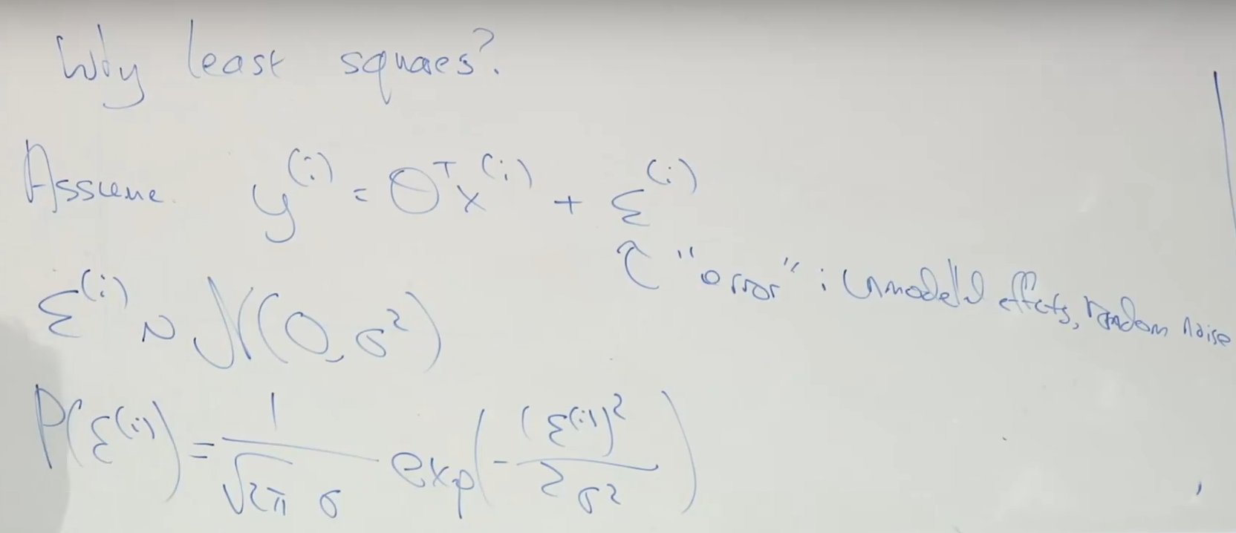

That noise will follow a normal/gaussian distribution.

**1 huge assumption**The error terms are IID’s( Independently and Identically Distributed) which means that the error term of 1 house is independent to the error term of another house 🡪 Which is not TRUE.

Because it is not possible to have the price of one house high and another house low in the same street.

But this assumption is good enough to make a pretty good model.

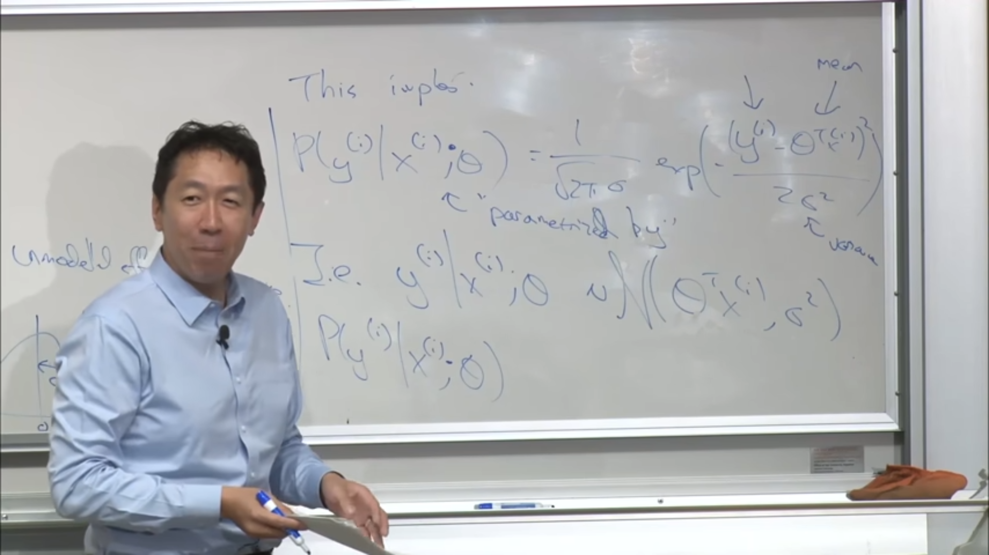

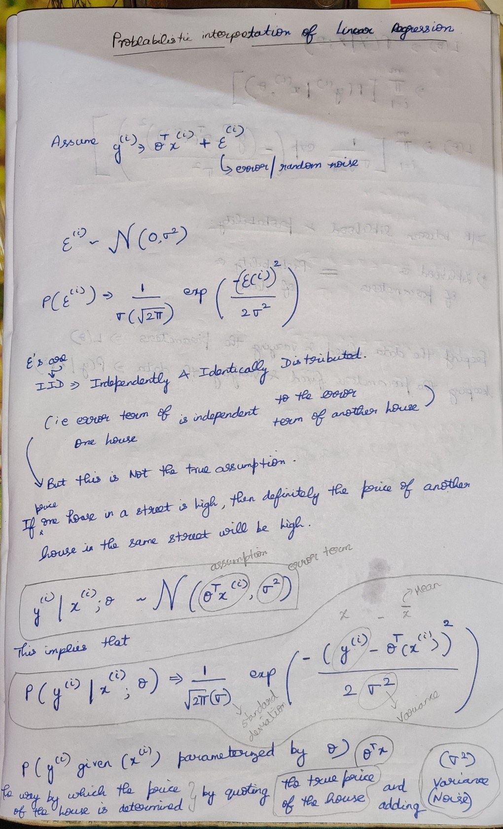

What is the probability that a particular house is priced??  
The way that the price of a house is determined is by taking the   
 🡪 new price of the house  
 🡪 adding the error term



**What is the reason for ; in the formula ??**P( | , ) 🡪 Probability of yi given xi and theta



P( | ; ) 🡪 Probability of yi given xi parameterized by theta



* is not the random variable, it is just a parameter that parameterizes this probability distribution.



Using Central Limit theorem, most of the error terms will cause the Gaussian distribution.